ASSIST/RRDF:

COMPREHENSIVE COMMUNITY DEVELOPMENT PROGRAMME IN LAKSHMIPURAM

PROGRESS REPORT: OCTOBER TO DECEMBER 2025

With the support of RRDF, The Netherlands, ASSIST has either executed or executing a comprehensive community development programme in all the villages of Edurumondi Island, Nagayalanka Mandal, Krishna District, Andhra Pradesh. Due to the success of this programme in all the island villages, the surrounding villages on the other side of Krishna River in Guntur District repeatedly requested ASSIST and RRDF for a similar development programme in their villages.

After looking into the situation of these villages, ASSIST as well as RRDF decided to look for donors to support a Comprehensive Community Development Programme in the village of Lakshmipuram. As the project in Gollamanda is coming to an end, Evert de Blok has contacted SRF (Stichting Reborgh Foundation, The Netherlands) and submitted the project proposal of Lakshmipuram village in Guntur District. The support of funding from SRF along with MORE Foundation through RRDF enabled us to start and implement a comprehensive development programme in Lakshmipuram for four years starting from 1st January 2022.

Lakshmipuram is a village in Rajukalava panchayat of Repalle mandal in Guntur district. This village is on the banks of Krishna River. Most of the villagers are backward and live on agricultural labour and fishing. When ASSIST started working in Elachetladibba from 2008, we had to go through this village. From then onwards, people of this village started asking ASSIST to work for their development, too. Later on, ASSIST took up villages under Edurumoni panchayat and started developing them. The pressure from this village increased, hence, ASSIST adopted this village from January 2022 with the support of SRF and MORE through RRDF, The Netherlands.

The total families in the village are 142, out of which Other Backward Castes are more in number with 124, Scheduled Castes are 3 families and Scheduled Tribes 15 families. The
total population is 442, males 213 and females 229.

This is the brief report on the activities executed in the 4th quarter of 2025 (October to December):

- People’s Organisation:

The Executive Committee of “Lakshmi Village Development Society” meets every month on 11th to discuss the various developmental issues relating to Lakshmipuram village. This VDS Committee comprising of 21 members (8 male and 13 female) is actively functioning in this village. These committee members along with the village elders and the field staff of ASSIST meet every month to discuss the activities being executed in the village including to be executed in the following month. Accordingly, three meetings were conducted during this reporting period.

The following is the summary of the discussions held during these meetings:

- Collection of monthly savings from the members of Women Self-Help Groups and depositing the same in the bank account.
- Ensuring timely repayment of monthly loan instalments along with the interest from the women who have availed loans from the Revolving Fund.
- Participation of committee members and community leaders in the leadership training camp organised by ASSIST.
- Getting audience for the cultural programme being organised by ASSIST on sensitisation.
- Ensuring all the children in the village studying 1st to 10th class to get update their Aadhaar E-KYC.
- Monitoring the regular attendance of school and college going children and adolescents.
- Dissemination of information to all on Mega Parents Meet (School Management Committee Meeting) being organised in the Government Schools.
- Ensuring the participation of all the villagers in VDS meetings.
- Preparing the people on the preventive measures to be taken during ‘Montha’ cyclone.
- Ensuring all 0–5 years age children to get pulse polio injections in the camp.
- Motivating the eligible women to go under Tubectomy operation.
- Obtaining the certificate to get pension for new members.
- Regular house visits by the medical staff to sensitise the people regarding seasonal diseases.
- To support loans to 21 needy members from revolving fund amount.
- To submit applications in gram sachivalayam (panchayat) for new house construction under PM Avas Yojana scheme.
- To register the NCD-CD survey in PHC.

Impact

- Since the majority of the committee members happens to be female, the involvement of majority population is visible in the developmental programmes.
- After banning drinking and gambling in the village, some of the vendors selling liquor secretly. All the committee members approached them and warned them to stop selling liquor. Those who did not follow the instructions were warned by the Government officials.

- Leadership Training Programme:

Two-day leadership training programme was held for 30 people (6 male and 24 female) on 11th and 12th November 2025 in Cyclone Shelter. VDS committee members, SHG women leaders and village elders have participated in the meeting. The resource persons for this training programme were:
- Mr. M. Naga Gopi Krishna, Engineer Assistant
- Mr. S. Mokshit Krishna, Welfare & Education Assistant
- Mr. M.V. Rama Rao, Deputy Director, ASSIST

The following topics were dealt by these resources in this two-day training camp:
- Violence and harassment on children
- Role of SHGs in village societies
- Importance of Education

Violence and Harassment on children

Child abuse refers to all forms of physical, mental and sexual abuse, exploitation, neglect, belittling, humiliating children as well as any actions that severely harm or exploit them for commercial gain are all considered as child abuse. Child abuse is any act by individuals in institutions that intentionally or unintentionally harms child’s health, dignity, survival or development. Child abuse should be understood from a holistic perspective. Child harassment and neglect mean physical and mental abuse, scolding and beating of the children in the school is called corporal punishment. According to the provisions of the educational speech Act section 17 prohibits scolding and beating of children which is known as corporal punishment.

An effective child protection policy provides clear guidelines for staff regarding their conduct. This demonstrates the commitment of the organisation and staff to child protection and helps to foster a child friendly environment in which staff interact with children while also ensuring the basic needs of children are met. It states that an effective child protection system with a complaint mechanism should be in place in the organisation. There should be a committee of members to receive the complaints. Their names should be displayed so that everyone knows and can access them.

Role of SHGs in Village Development:

The participants were enlightened with the key topics: Understanding SHGs and Grama Samakhyas, Structure and objectives of Grama Samakhyas, Importance of federation for collective strength and role of SHGs in Grama Samakhyas. Self-Help Groups (SHGs) play a vital role in strengthening Grama Samakhyas, which are village-level federations of SHGs. To enhance the understanding and active participation of SHG members in Grama Samakhyas, a structured training programme was organised. The programme aimed to build clarity on roles, responsibilities, and coordination mechanisms between SHGs and Grama Samakhyas for effective village-level development. SHGs play a crucial role in mobilising the community on social issues such as prevention of alcoholism, child marriage, domestic violence, and promotion of girls’ education. SHGs contribute to strengthen the financial base of Grama Samakhyas through regular savings and proper loan management. SHGs identify and nurture women leaders who take up responsibilities at the Grama Samakhya level. SHGs support and implement activities related to health, nutrition, sanitation, education, and livelihoods at the village level. SHGs play a crucial role in mobilising the community on social issues such as prevention of alcoholism, child marriage, domestic violence, and promotion of girls’ education.

Impact:

- The training program significantly enhanced the capacity of SHG members to actively contribute to Grama Samakhyas.
- By strengthening the linkage between SHGs and Grama Samakhyas, the programme laid a strong foundation for inclusive, transparent, and sustainable village-level development led by women.

Importance of Education:

Deputy Director M.V. Ramarao emphasised the importance of education in society, especially to the parents of children and advised them to accustom their children to Anganwadi school when they are 3 years old and then send them to Government school once they complete 5 years of age. It was stated that the education of children should not be neglected and that, in line with private schools, English medium has been established from the 1st grade and quality education is being provided by skilled teachers in government schools, also. ASSIST has set up play equipment in the school for children to play games and has donated bags, notebooks etc for the school going children. He enlightened that the education is the foundation for individual growth and overall social development. It empowers people with knowledge, skills, values, and confidence to lead a dignified life. Education helps individuals think critically, make informed decisions, improve their livelihood opportunities, and actively participate in the development of society. An educated person not only improves their own future but also contributes positively to the family, community, and nation.

Government schools play a vital role in providing inclusive and equitable education, especially to children from economically and socially disadvantaged backgrounds. Government schools provide free and compulsory education, along with essential facilities such as textbooks, uniforms, mid-day meals, scholarships, and healthcare support, which reduce the financial burden on poor families and encourage regular school attendance.

Impact

The participants are enlightened the importance of education and they are encouraged to send their children to government schools, which will lead to sustainable development and brighter future for them.
- Awareness Generation:

Cultural Programme

Cultural camp was organised on 19th November 2025 at the cyclone shelter around 6.00 pm by ASSIST Cultural wing MELUKOLUPU to sensitise the target population on the issues in the village. It was performed through songs, skits and play-lets for 2 hours in the evening. It was attended by 89 people (21 male elders, 37 female elders, 14 boys and 17 girls).

The topics dealt in this cultural programme are:

- Sensitisation on health, hygiene, water and sanitation aspects to promote healthy communities. In this winter season, the audience were enlightened on the spread of mosquitoes in the stagnated water. Hence, the villagers have been cautioned to prevent the stagnated water around their house surroundings and also in the drainages. They were advised to spread the bleaching powder along the streets in this season. Preventive measures to be followed in taking drinking water. Personal hygiene, environmental cleanliness, seasonal diseases like cold, cough, dengue fever were also explained clearly through maims, skits.
- Sensitisation on going outside for defecation is a bad and unsafe practice. Open defecation spreads harmful germs, bacteria, and parasites that cause diseases such as diarrhoea, cholera, typhoid, and worm infections, especially among children and elderly people. Using toilets is especially important for the safety and dignity of women, girls, elderly, and differently abled persons. Going outside early in the morning or at night exposes women and girls to harassment, snake bites, and accidents. Toilets at home provide privacy, security, and self-respect.
- Necessity and importance of monthly savings to the possible extent compulsorily to have some money in case of any need or urgency. Finance control by avoiding lavish and unnecessary expenses to boost up one’s image. Avoid borrowing the money at high rate of interest to invest in functions like marriages, etc. Benefits in joining the Women Self-Help Group to get acquainted with other women in the village and to avail the internal and bank loans to enhance their economic status. Process to avail the bank loans for livelihood interventions, especially through self-help groups. The cultural team played a skit ‘Kanuvippu’ how a family faced difficulties with savings in need and how a family couldn’t face who have so savings.

Impact

The villagers have followed the preventive measures by doing bleaching in the wastewater canals, roadsides etc.

House Visits

142 families have been visited by the field staff of ASSIST during this quarter. The particulars are as follows:

- 24 families who are living in thatched houses and old slab houses were motivated to stay safe in Lakshmipuram school during Montha Cyclone time i.e. from 26-10-2025 to 28-10-2025 (3 days). All the families in the village were advised to take appropriate precautions for the elderly and children.
- Farmers have been informed in advance about Montha cyclone and advised to take appropriate precautions.
- 37 fishermen were advised to bring their 37 boats to the shore and secure them carefully.
- All the staff daily visited all 142 families and advised not to go for fishing for 3 days during Montha cyclone time.
- VDS members also announced in the village not to go for fishing.
- 21 needy families were identified and given loans at low interest rate for cultivation.
- It was observed in the first visit that 14 families have been bringing essential commodities in plastic covers and throwing them around their houses. They were enlightened on the problems by throwing the plastic covers in the streets. It was observed in the second visit to these 14 families there has been change among 11 families and no plastic covers are visible in and around their houses.
- 36 families having school age children were visited and motivated the children and parents to send their children to school regularly without any drop-out by letting them know the necessity and importance of education.
- Washing Platforms established by 140 families are making use of them properly and water is not getting stagnated around their houses.
- 36 students of parents were informed to update their children Aadhar updates in the camp organised in village sachivalayam.
- Through house visits, 32 children (0-5 years) - 16 boys and 16 girls - were identified and given pulse polio drops.
- If there are any eligible people in the village who need to apply for PM Avas Yojana scheme are advised to apply in village sachivalayam (panchayat).

Impact

- Majority of the families have been inculcated the habit of consuming safe drinking water to enhance their health status.
- All the families have started giving importance on environmental sanitation having realised the consequences with the unhealthy environment and stagnated water around their houses.
- Biometrics of 36 students were updated.
- During cyclone period people were managed to use vegetables from their own kitchen gardens and helped others also.

- Children and Education:

The village has 16 children (8 boys and 8 girls) in the age group of 0-2, 16 children (8 boys and 8 girls) in the age group of 3-5.

Among them, 16 children (8 boys and 8 girls) of 3-5 age group are attending the local Government Anganwadi Centre. Here, the children are provided nutritious diet apart from preparing them for schooling through the variety of games, pictures and audio-visual aids. Their height and weight are being monitored constantly by maintaining register in the centre. Anganwadi teacher is also taking care of the pregnant women and lactating mothers by giving the supplementary nutritious diet to these candidates.

There are 67 children (26 boys and 41 girls) in the age group of 6-14 and all of them are attending the schools either in the local school or outside. Details of these children are given under:

Class | Total studying |  |  | Local Schools |  |  | Hostels outside
Class | Boys | Girls | Total | Boys | Girls | Total | Boys | Girls | Total
1st class | 3 | 2 | 5 | 3 | 2 | 5 | - | - | -
2nd class | 2 | 2 | 4 | - | 2 | 2 | 2 | - | 2
3rd class | 3 | 10 | 13 | 2 | 8 | 10 | 1 | 2 | 3
4th class | 5 | 3 | 8 | 5 | 3 | 8 | - | - | -
5th class | 2 | 3 | 5 | 2 | - | 2 | - | 3 | 3
6th class | 2 | 7 | 9 | 2 | 7 | 9 | - | - | -
7th class | 3 | 5 | 8 | 3 | 5 | 8 | - | - | -
8th class | 3 | 6 | 9 | 3 | 6 | 9 | - | - | -
9th class | 3 | 3 | 6 | 2 | 2 | 4 | 1 | 1 | 2
Total | 26 | 41 | 67 | 22 | 35 | 57 | 4 | 6 | 10

Out of 67 children, 36 children (14 boys and 22 girls) are studying in local elementary school and 21 children (8 boys and 13 girls) are studying in Lankavanidibba High School while 10 children (4 boys and 6 girls) are studying in boarding schools outside the village. All of them are attending school without fail. Dokka Seethamma Mid-Day Meal Scheme is being provided to meet nutritious meals to school children in the State.

The following are the details of students of tenth and above from the village:

Class | Hostels |  |  | Remarks
Class | Male | Female | Total | Remarks
10th class | 3 | 3 | 6 | Studying in the nearby high school.
1st Year Intermediate | 6 | 2 | 8 | All are studying in colleges outside staying in Government hostels.
2nd Year Intermediate | 2 | 4 | 6
Degree 1st year | 1 | 1 | 2
Degree 2nd year | 1 | 1 | 2
Degree 3rd year | - | 2 | 2
B.Tech. 1st year | 1 | 1 | 2
Total | 14 | 14 | 28
28 candidates (14 male and 14 female) are attending classes from 10th to graduation and above level.

Vocational Training:

15 candidates (3 male and 12 female) having studied Intermediate and Degree and idle at home were given training in Computer Applications, Desktop Publishing and Accounting Package. While 15 have successfully completed the training, 8 candidates (3 male and 5 female) have obtained jobs and living on it. Remaining 7 candidates are trying for appropriate jobs.

Impact

Having seen the good progress of youth in obtaining suitable jobs after having completed their education or vocational training, both the adolescents and youth are motivated to concentrate on their studies and to attain better opportunities for their growth.

- Community Health:

The village has 3 pregnant women in the beginning of this quarter. In this quarter, three more woman got added. Hence, pregnant women have become six as of now. All the three are being given T.T. injections as required.

The village has 4 lactating mothers in the beginning of the quarter. Government Health Worker is doing the monthly check-up to all these women and following immunisation chart for their safety and proper growth of children.

In addition to this, 32 children (16 boys and 16 girls) of 0-5 age group are being monitored by the Health Worker following the immunisation chart.

140 families have established washing platforms under the programme and they are making use of them properly. With the use of these platforms, the surroundings of wash area are clean and dry. The used water is being diverted to the kitchen gardens. Hence, cleanliness and greenery are also being promoted besides conservation and preservation of water resources.

10 dustbins are provided in the village and villagers are using them properly.

142 families were provided with varieties of seeds like cucumber, ridge gourd, lady finger, cluster beans, egg plant and tomato etc., to promote kitchen garden. These families are getting organic free vegetables and green leaves not only for them also giving to other families.

Impact

- People have started giving greater importance for health, hygiene and environmental sanitation in the village. During the floods, the VDS committee members have taken special attention and faced the situation cleverly.

- Women Empowerment:

Self-Help Groups

12 Self-Help groups with 124 members meet on or before 5th of every month and contribute @ ₹ 100 per member per month. The savings are deposited in their respective bank accounts, and the accounts are maintained up to date.

Particulars | Amount  in INR
Balance of 12 groups as on 30th September 2025 | 952,200
Add: Savings of 124 members of 12 groups (Oct-Dec 25) | 37,200
Total | 989,400
Internal loans recovered in this quarter – Principle | 197,000
Internal loans recovered in this quarter – Interest | 49,600
Total | 1,236,000
Less: Internal loans extended to 8 members of 4 groups | 160,000
Balance as on 31st Dec 2025 | 1,076,000

Details of internal loans:

Particulars | Amount  in INR
Internal loans outstanding as on 30th September 2025 | 1,686,400
Less: Internal loan recovered (Oct-Dec 25) – Principle | 197,000
Total | 1,489,400
Add: Internal loans extended to 8 members of 4 groups | 160,000
Internal loans outstanding as on 31st Dec 2025 | 1,649,400

Bank Linkage Loans

Particulars | Amount  in INR
Total Bank loans outstanding of 12 groups as on 30th Sept 2025 | 3,432,000
Less: Loans repaid by 12 groups in this quarter (Oct-Dec 25) | 610,000
Bank loans outstanding of 12 groups as on 31st Dec 2025 | 2,822,000
Impact

There is a good improvement in the village as they have stopped borrowing money at high interest rates by mortgaging the properties. Availability of revolving fund through the banks and Self-Help Groups has changed the financial stability in the village. With the timely repayments, the women are able to borrow a loan of Rs. 100,000- to Rs. 200,000- through their SHGs and Bank linkages.

- Housing:

ASSIST along with the local Government supported 30 families till the end of last quarter. Six families got the sanction of their houses newly in this quarter. The total number of houses in this village have increased to 36 and their status is as follows:

Status | As on 30th Sep 2025 | As on 31st Dec 2025
Not started | - | 6
Basement | 2 | -
Lintel level | 1 | 2
Roof level | 2 | 1
Completed | 25 | 27
Total | 30 | 36

Repairs/Renovations of Old Houses

32 old houses completed repairs till the last quarter and in this quarter two more families were extended support. Hence, the total number of houses being renovated have increased to 34 in this village.

Impact

Matching grant support under the project has enabled the families to get the sanctioned amount from the Government and to construct a secure shelter, which has been their dream. Now, they feel secure as they have permanent house withstanding any disaster. New houses not only given them secured shelter, they also paved the way for provision of piped water supply to all the families and other basic infrastructure in their habitation.

- Land Development:

The village has 58 acres of land and the total land is being cultivated with paddy crop this year as well. Harvest has been completed and the yield achieved this year is in the range of 22 to 26 bags per one acre. Paddy bag of 76 kgs is disposed in between Rs. 1,500- to Rs. 1,600-. Accordingly, the profit per acre is estimated at Rs. 6,610- during this year.
- Government Pensions:

56 persons are getting different types of pensions from the government as per the details given below thereby making life easier to the people:

Pension Name | Members  receiving  pensions | Monthly  Each  INR | Monthly  Total  INR
Old age | 12 | 4,000 | 48,000
Widow | 12 | 4,000 | 48,000
Fishermen | 27 | 4,000 | 108,000
Single woman | 1 | 4,000 | 4,000
Persons with Disability | 4 | 6,000 | 24,000
Total | 56 |  | 232,000

- Work Units for landless families:

During this reporting period, 20 landless families were extended support to venture into a variety of livelihood programme for their upliftment. Particulars of loans given to these 20 landless families at the rate of INR 10,000- each are as follows:

SN | CATEGORY | NUMBER
1 | Bangles business | 1
2 | Cloth business | 1
3 | Milch animal | 2
4 | Boat repair | 3
5 | Prawn vending | 4
6 | Fish vending | 3
7 | Petty shop | 1
8 | Goat rearing | 1
9 | Fishing nets | 3
10 | Small hotel | 1
 | Total | 20

- Revolving Fund:

All the 142 families of Lakshmipuram are the members of the Village Development Society and all have paid the share capital for the promotion of revolving fund in the village. They are also doing periodic savings as well. They are availing of loans from this fund towards livelihood activities. The status of this revolving fund is as follows:

Particulars | As on  30th Sep 25  INR | Oct-  Dec 2025  INR | As on  31st Dec 2025  INR
RECEIPTS:
Membership fee | 7,100 | - | 7,100
Share capital | 71,000 | - | 71,000
Matching Grant | 71,000 | - | 71,000
Savings | 172,690 | 20,600 | 193,290
Loan Repayments | 678,000 | 158,000 | 836,000
Interest on loans | 40,230 | 10,480 | 50,710
Bank Interest | 9,867 | 780 | 10,647
Project grant for landless families | 200,000 | - | 200,000
Total | 1,249,887 | 189,860 | 1,439,747
PAYMENTS:
Loans given | 1,010,000 | 210,000 | 1,220,000
Community Development Works | 24,000 | - | 24,000
Closing balance | 215,887 | 20,140 | 195,747
Total | 1,249,887 | 189,860 | 1,439,747

Particulars of loans given to 21 families at the rate of INR 10,000- each from the Revolving Fund during this quarter are as follows:

SN | CATEGORY | NUMBER
1 | Fishing Nets | 11
2 | Boat Repair | 6
3 | Agriculture | 3
4 | Prawn Nets | 1
 | Total | 21

Place: Chilakaluripet M. Vishnu Priya J. Ranga Rao
Date: 21st January 2026 Associate Director Director, ASSIST

Sensitisation Programmes
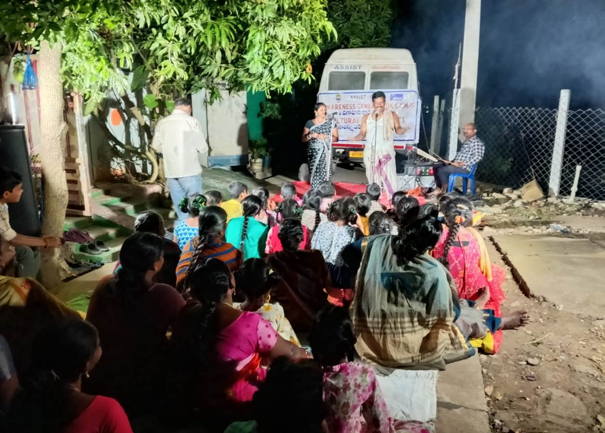

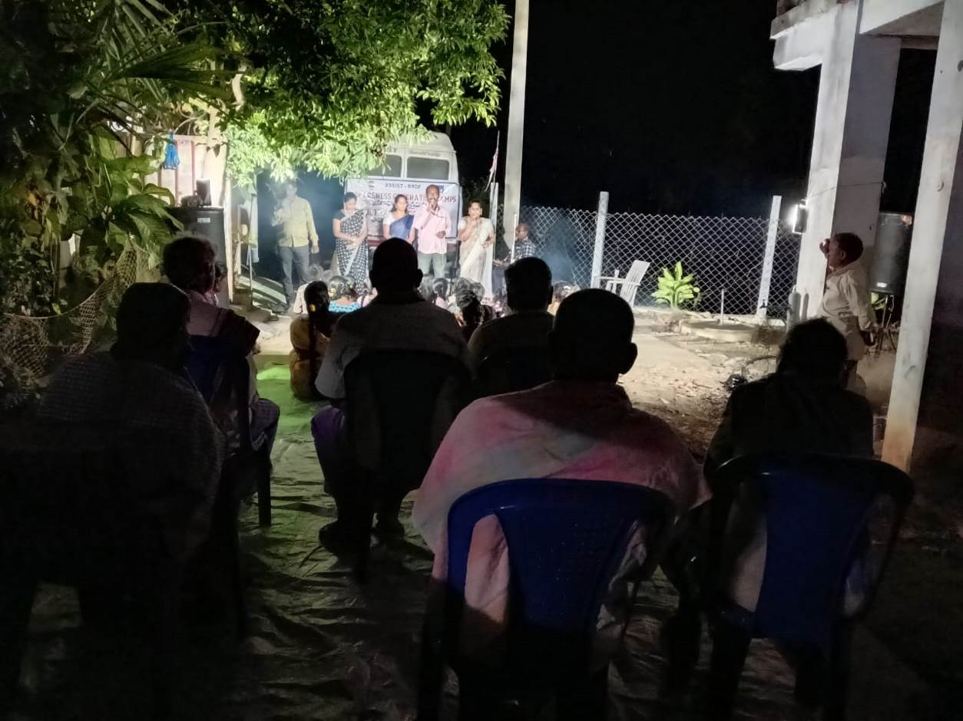
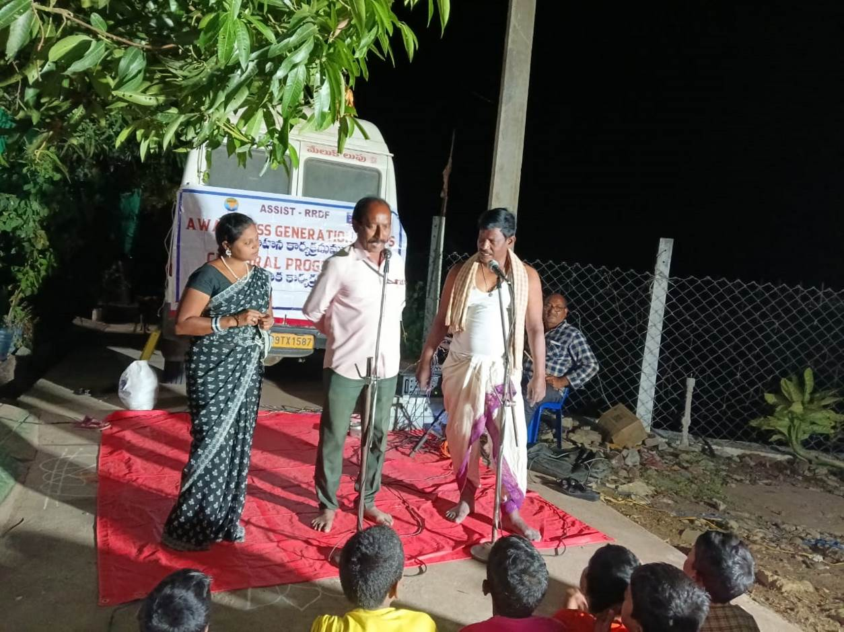

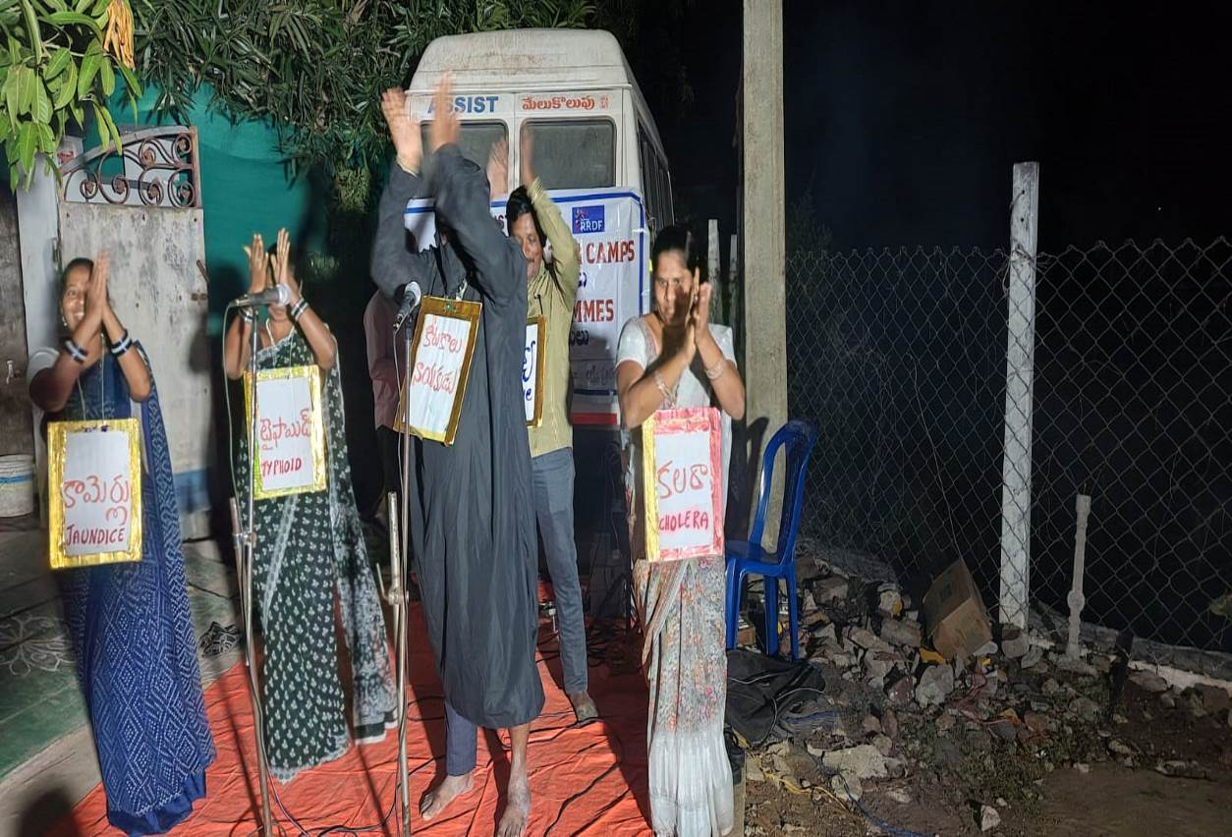

Regular House visits by Community Organiser
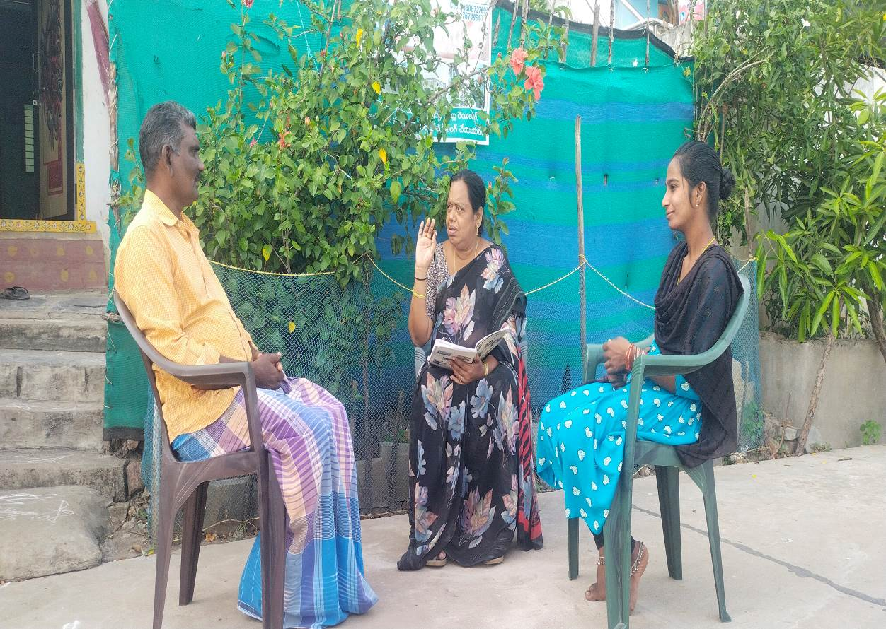

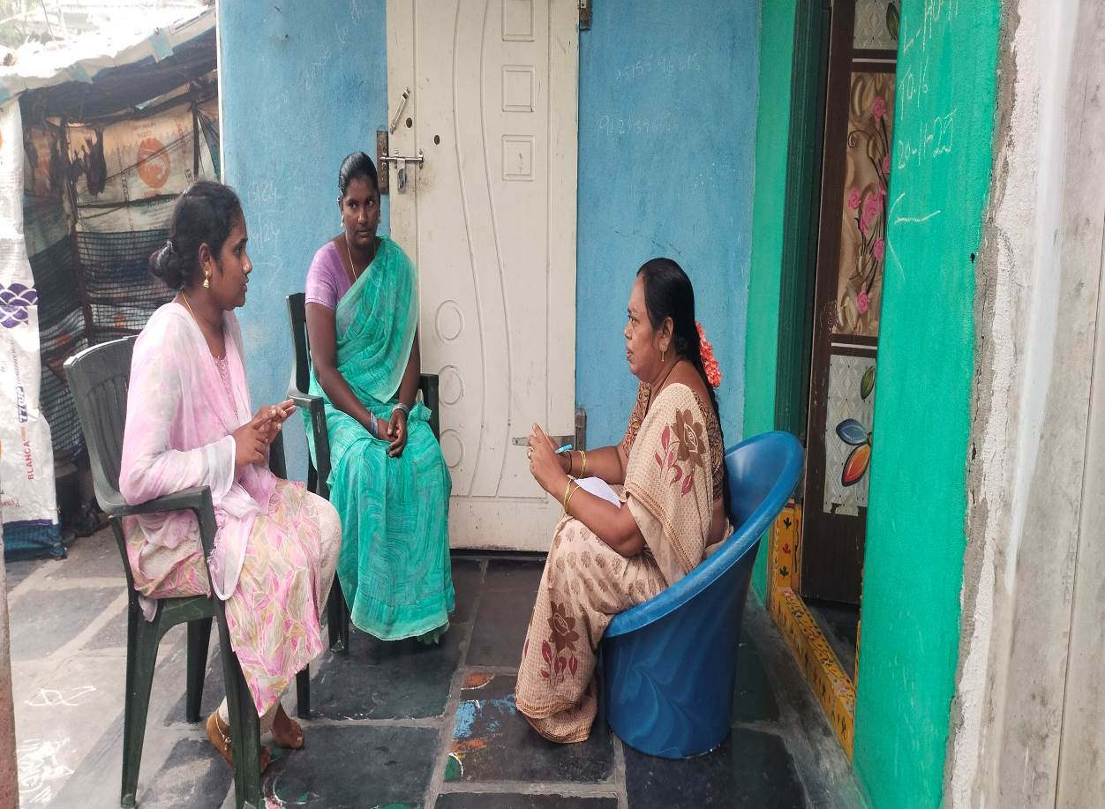
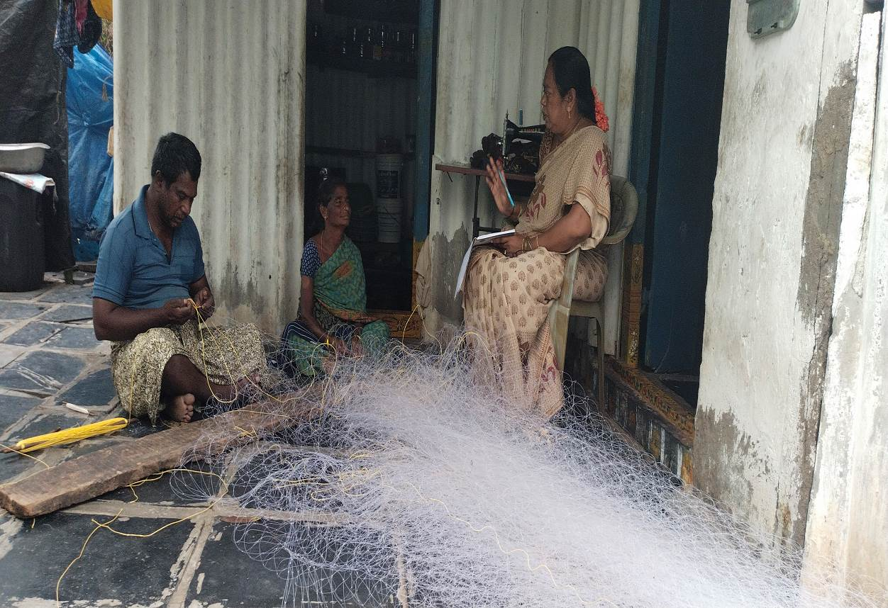

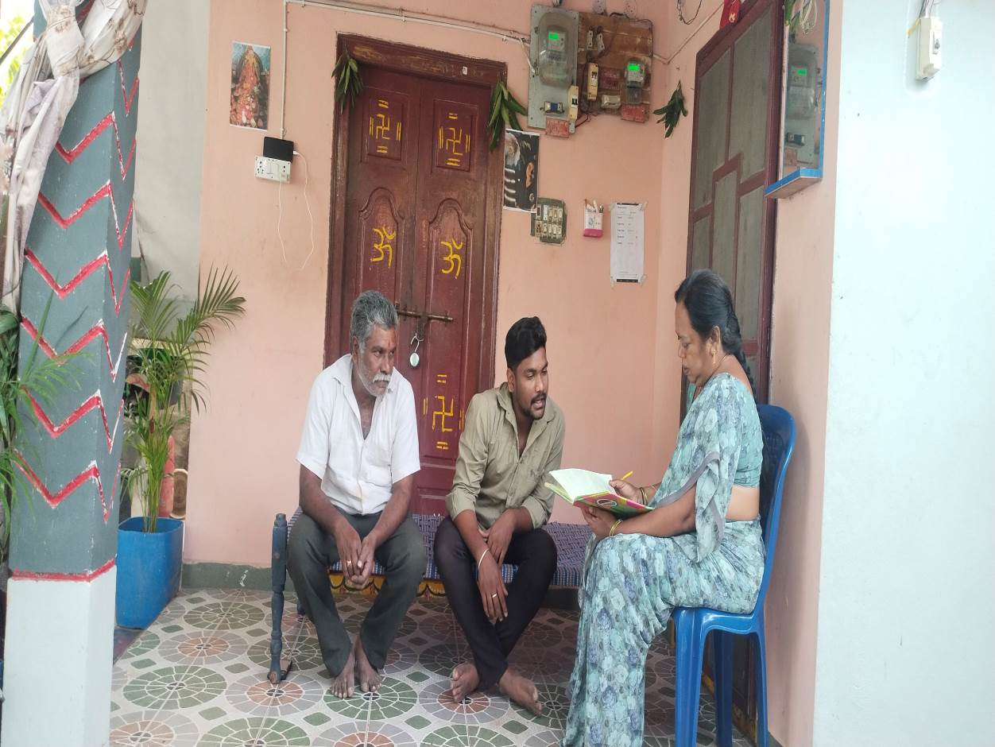

Children in School
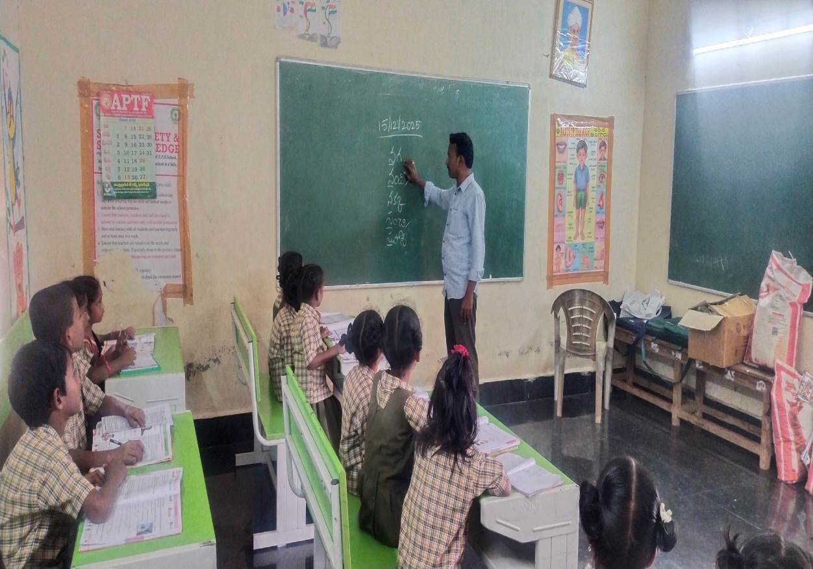

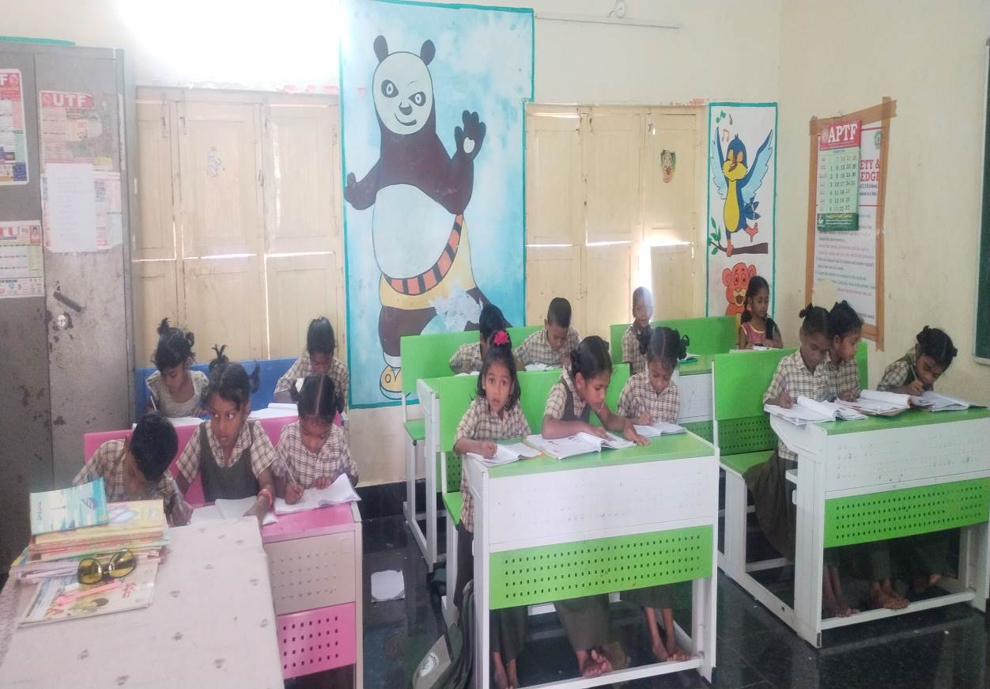
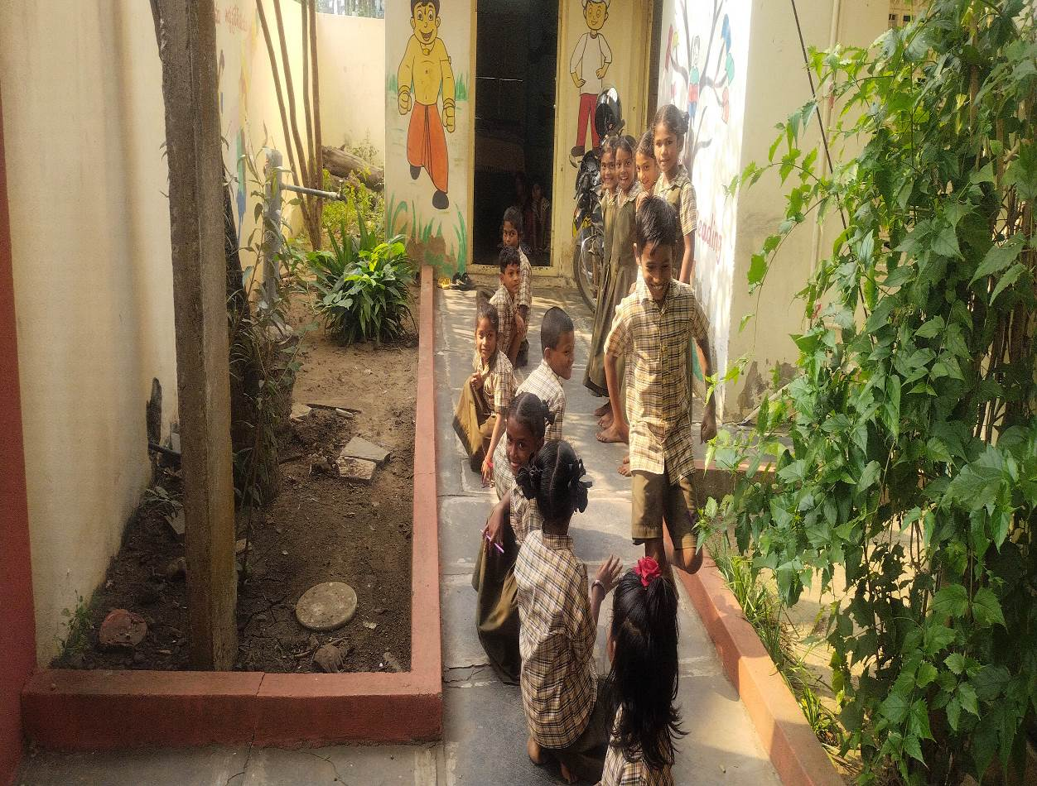

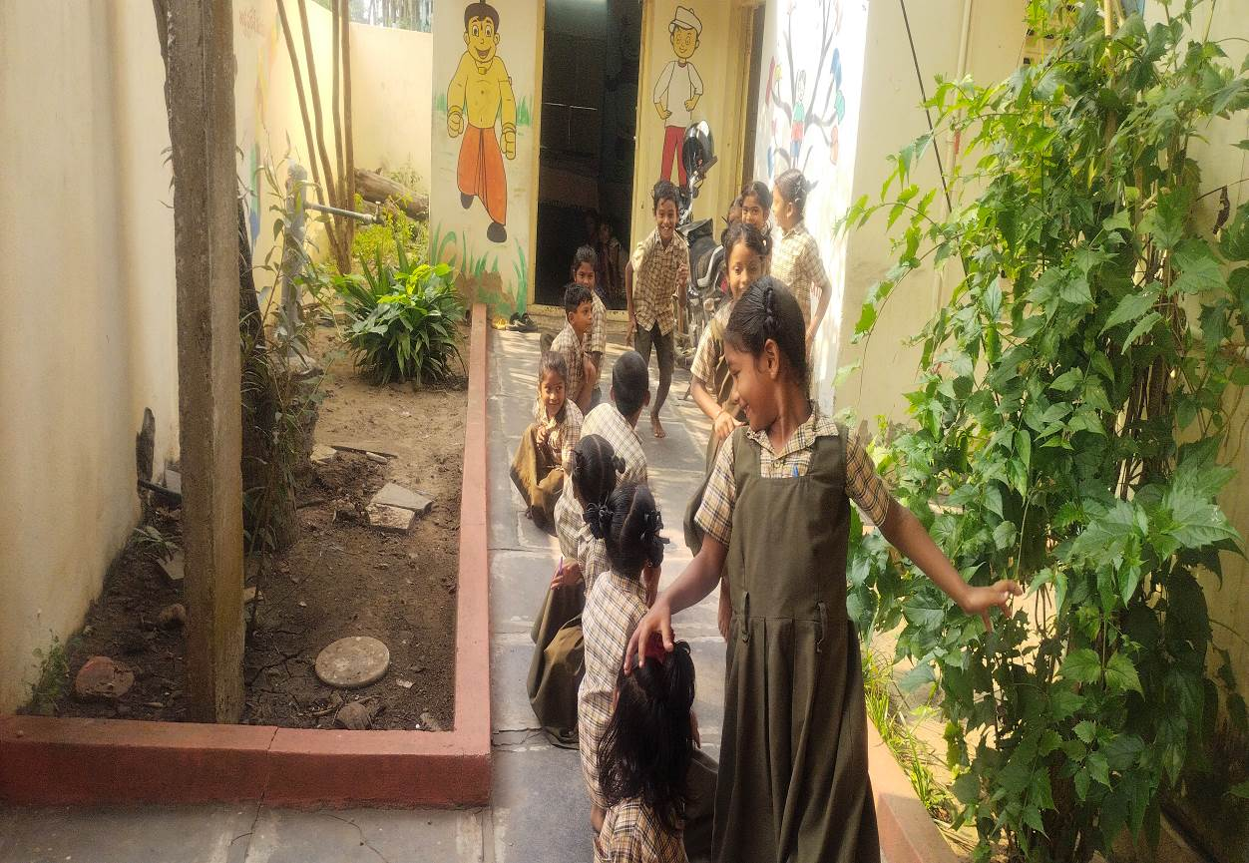
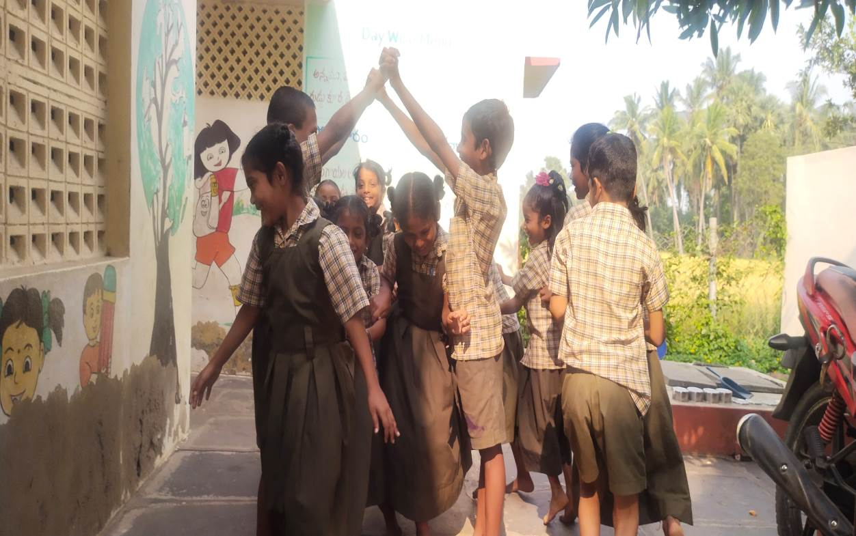

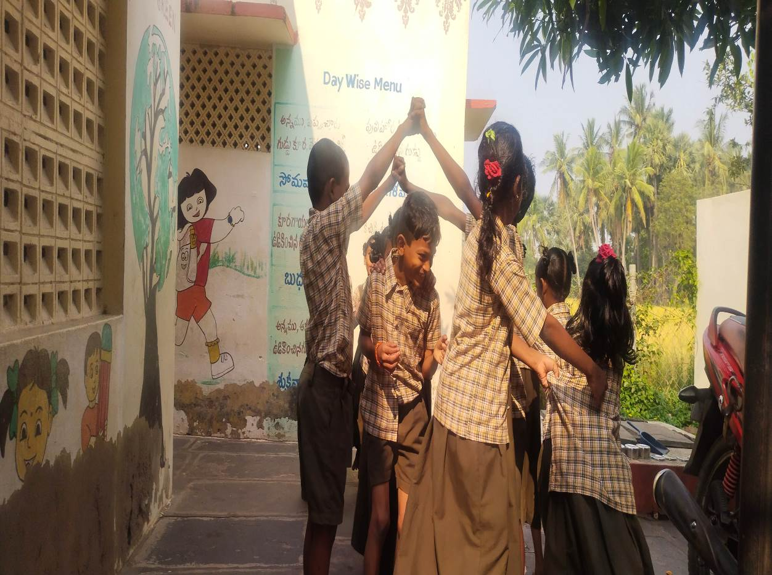

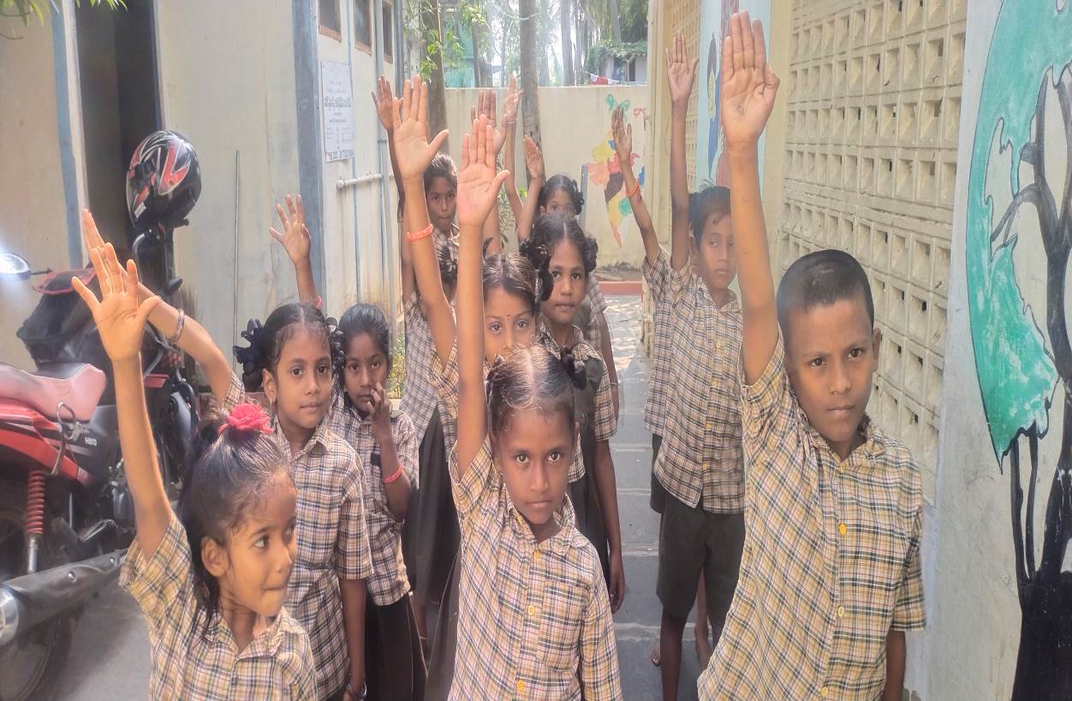

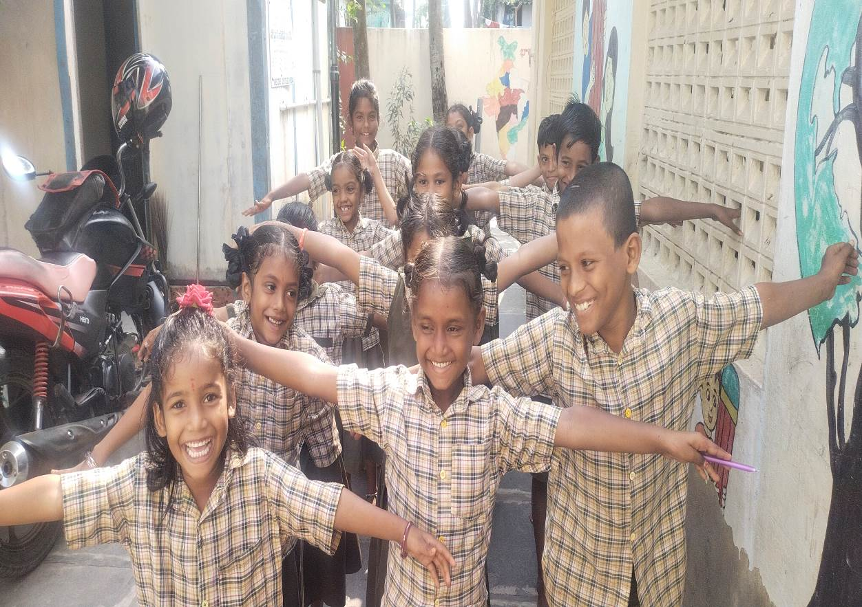

Community Dust Bins
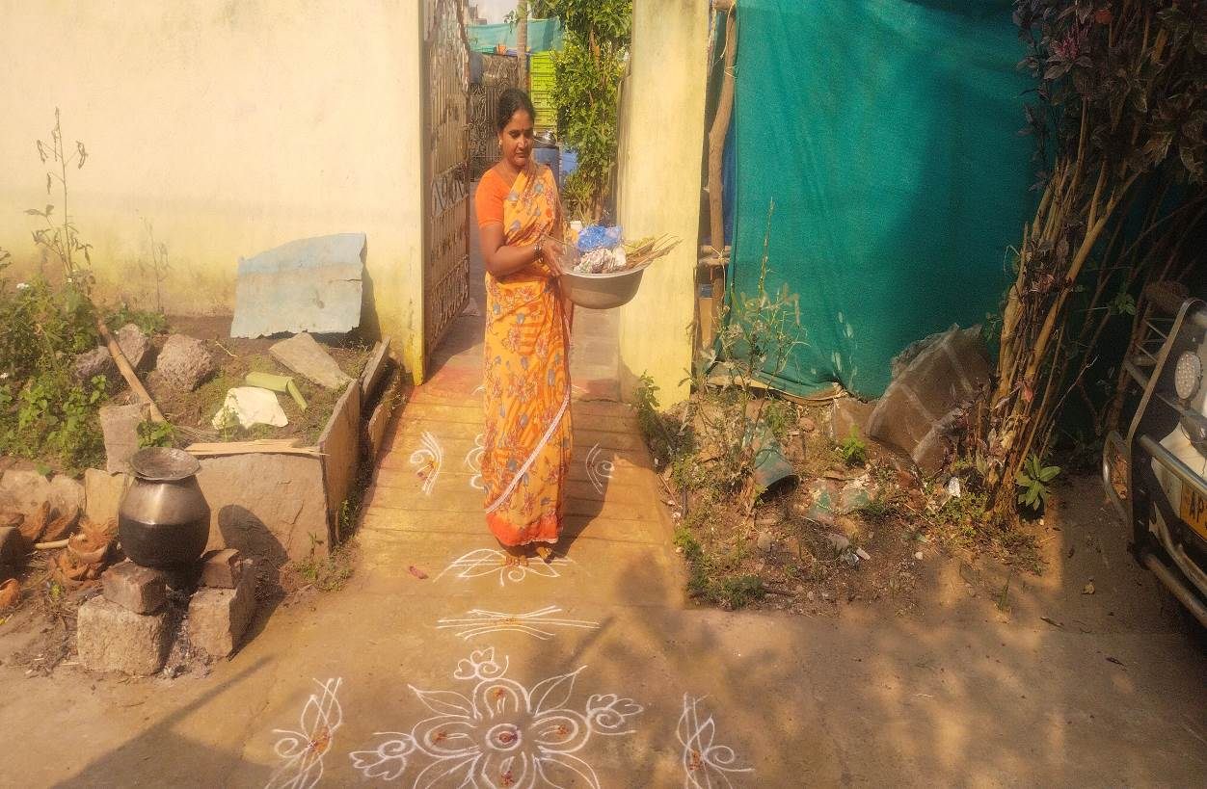

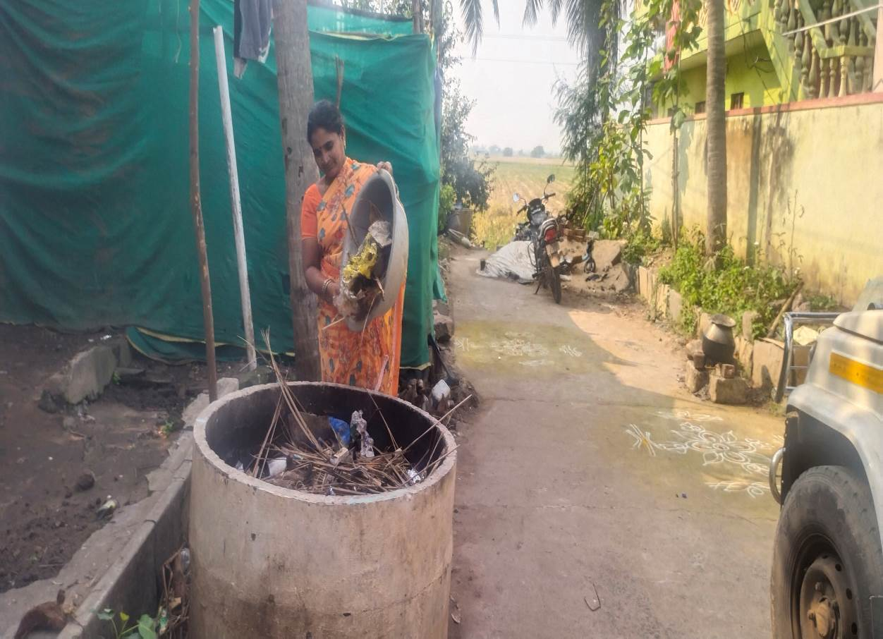
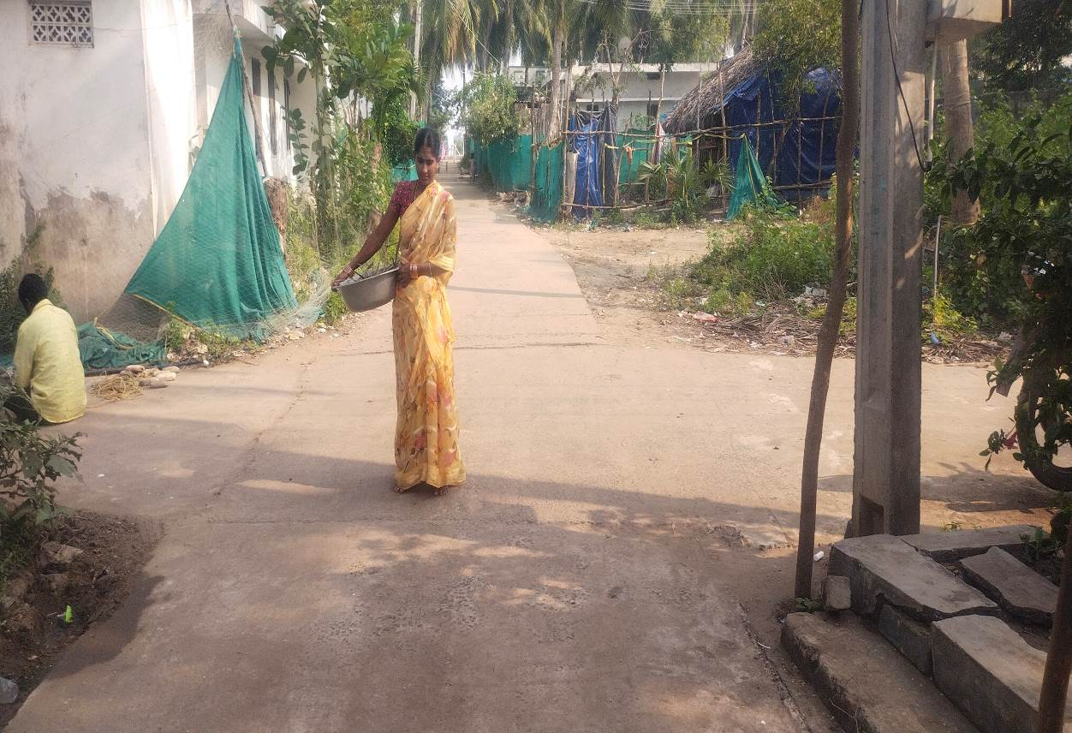

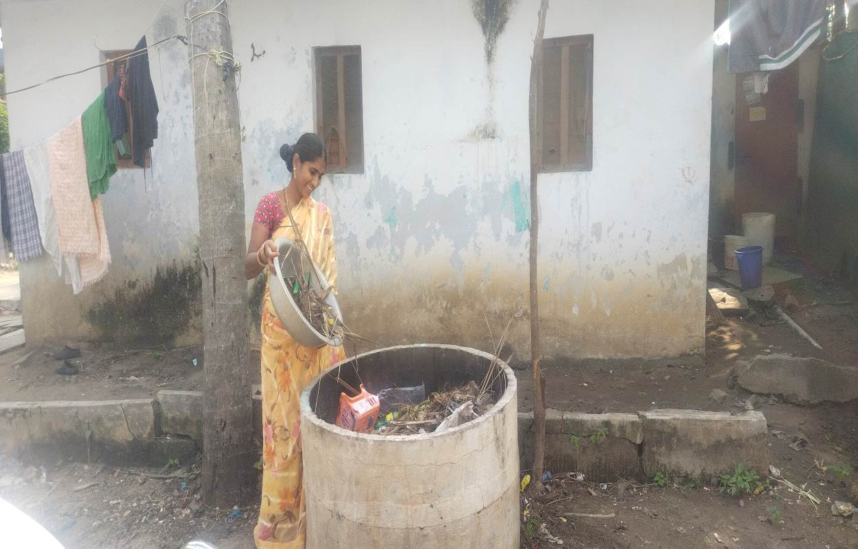

Monthly Meetings of Self- Help Groups
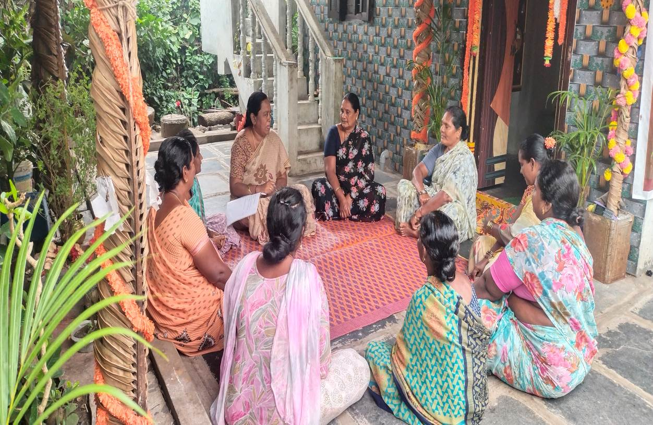

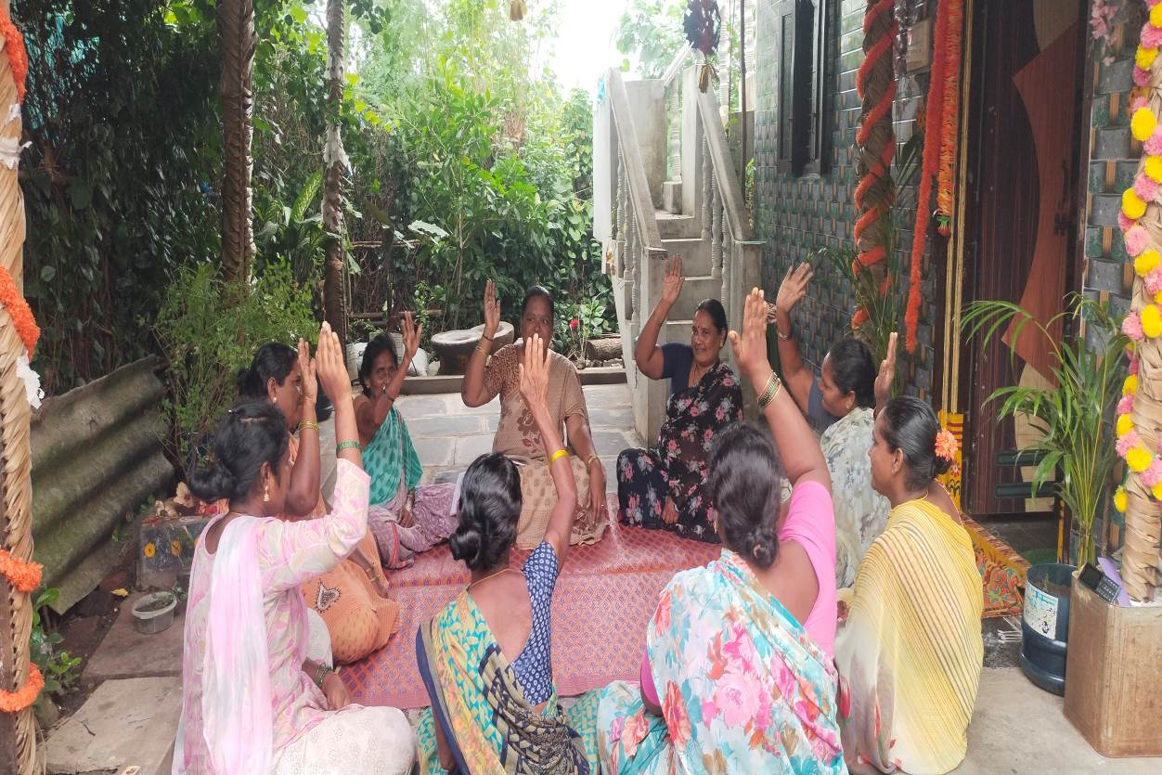

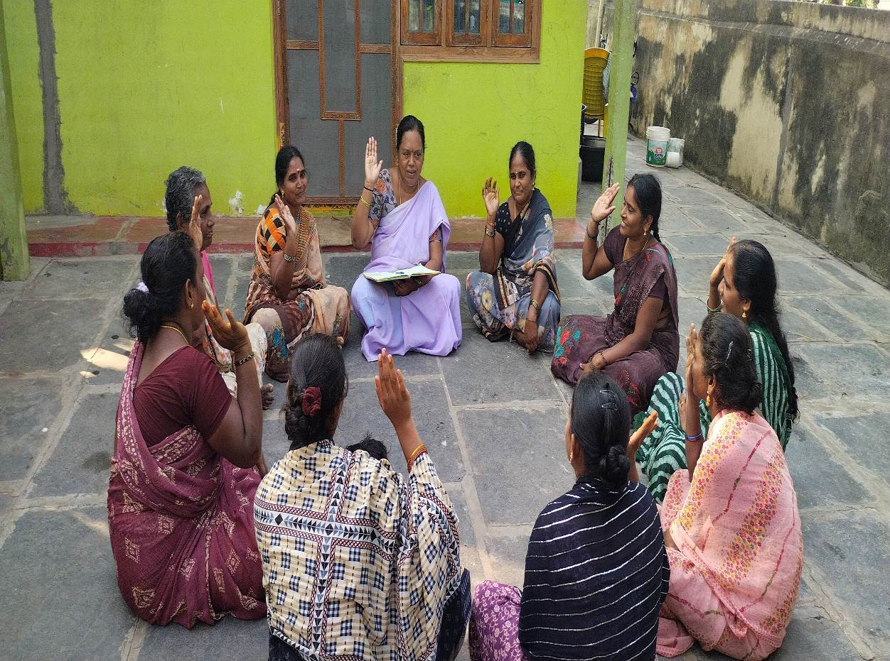

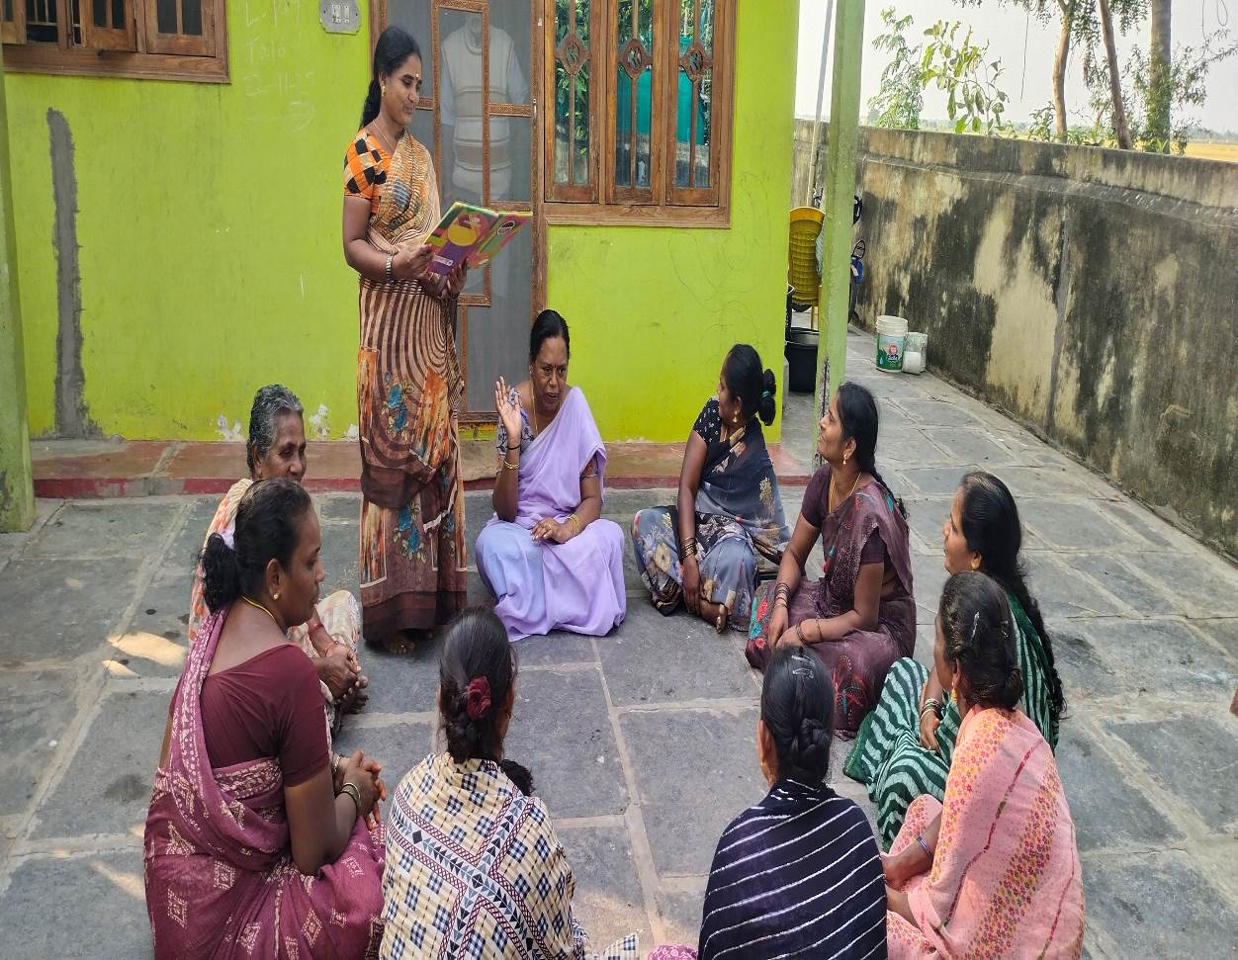
Taking care of Health by Government Health workers
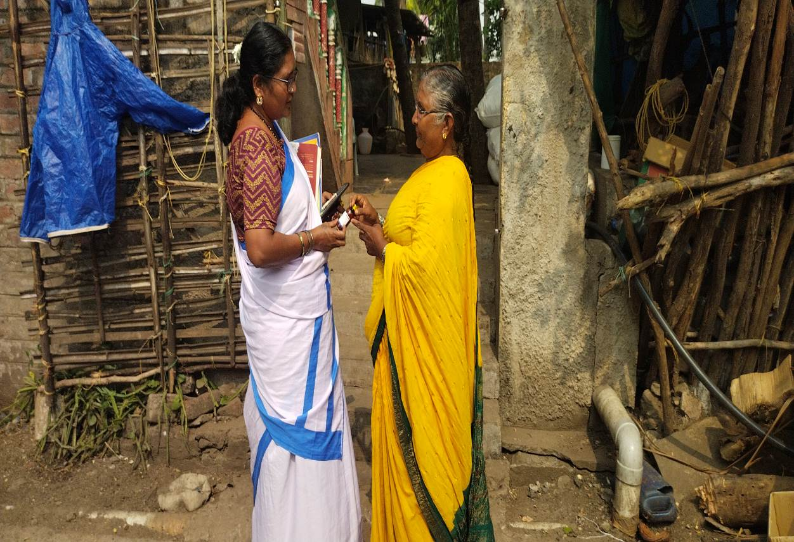

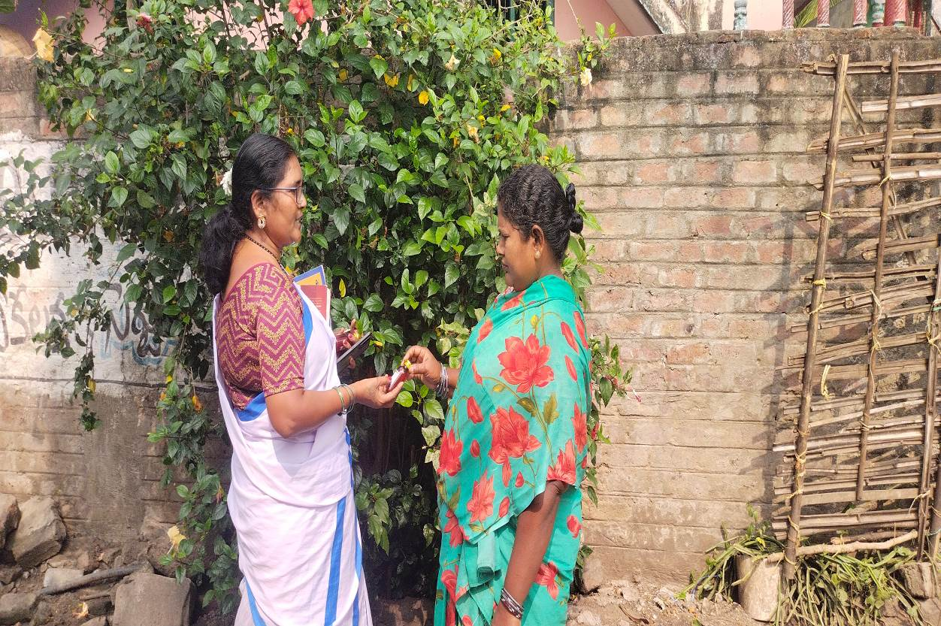
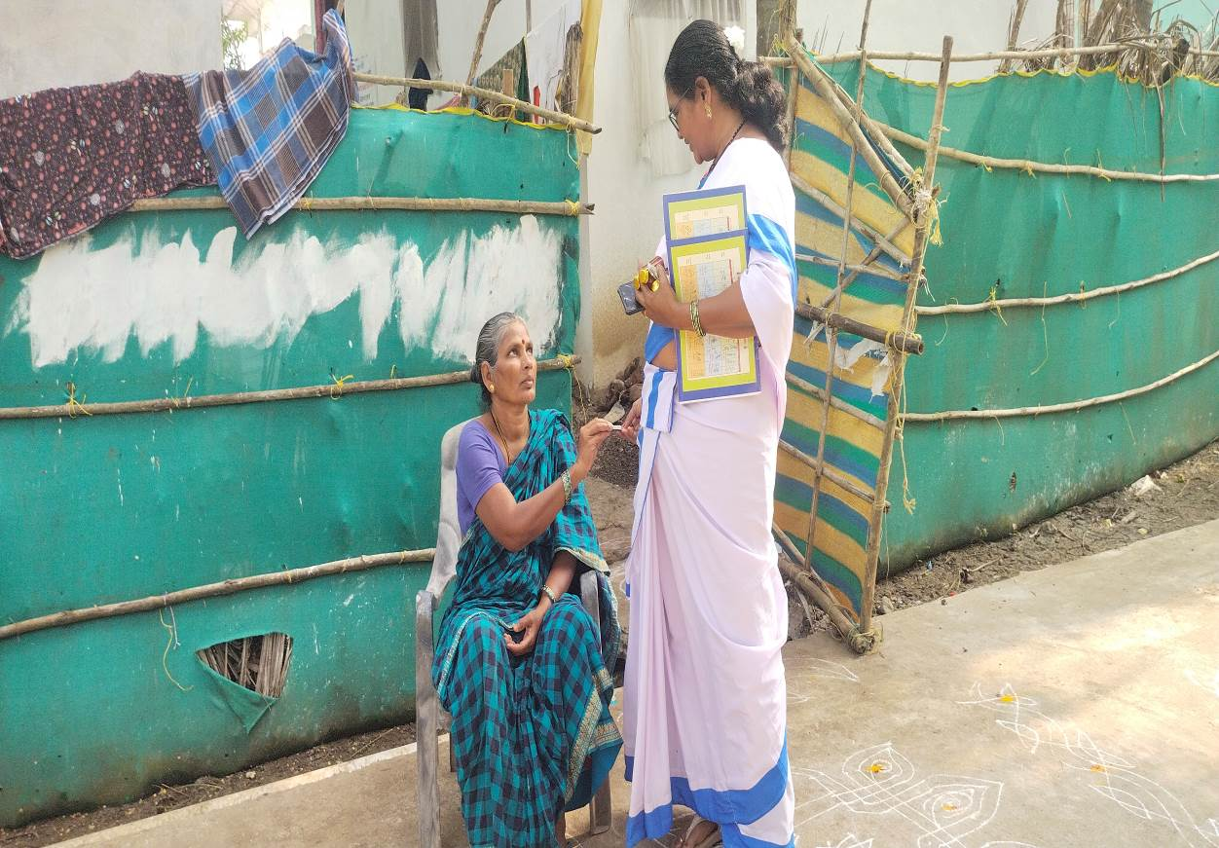

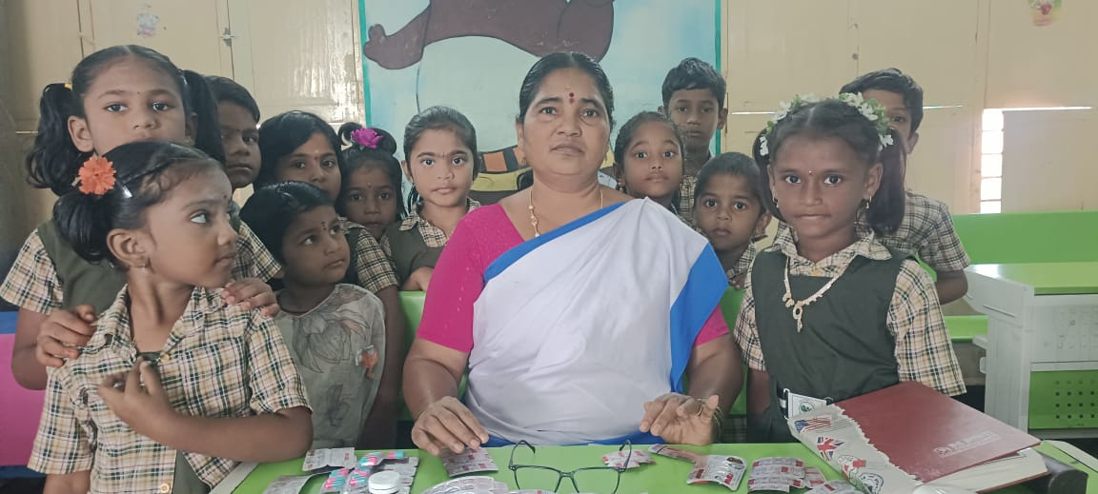

Housing
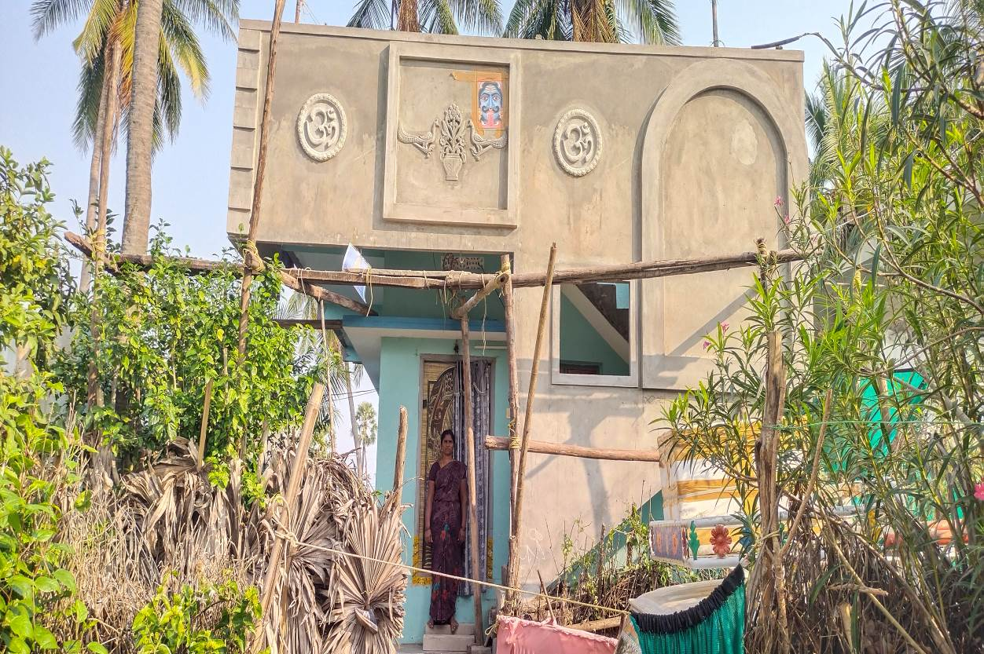

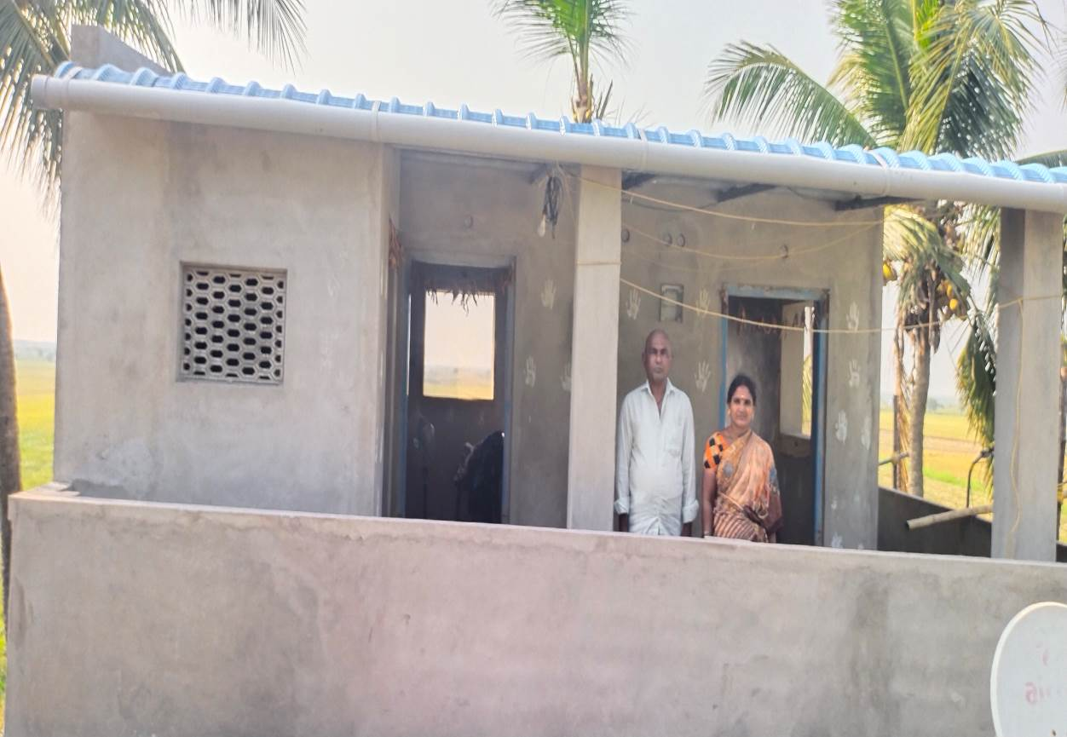
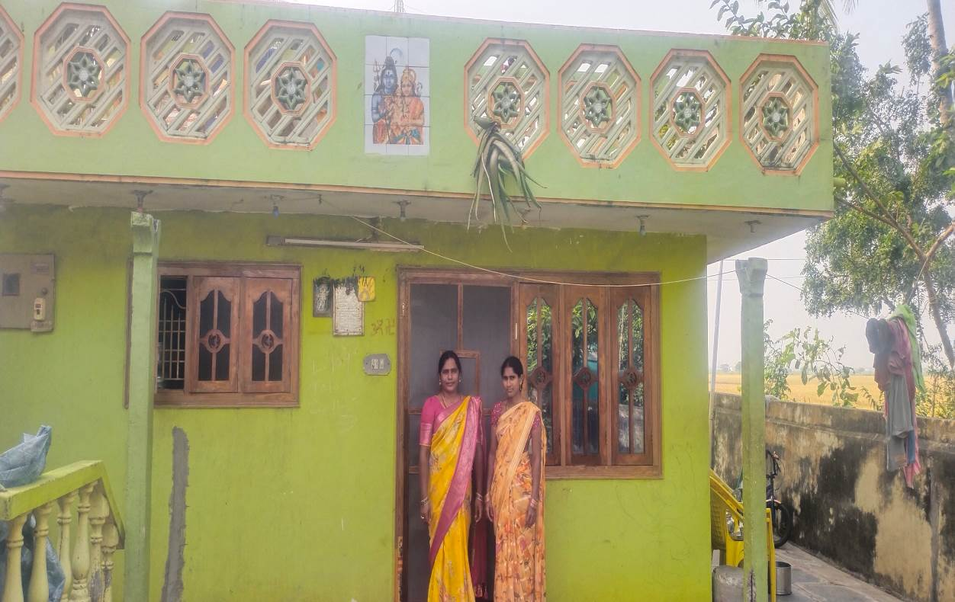

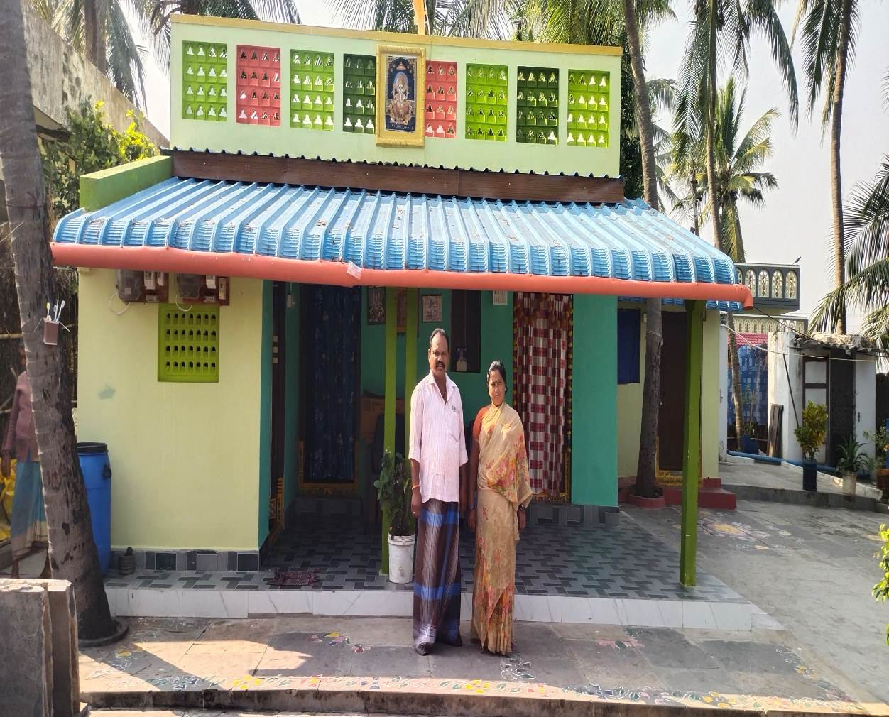
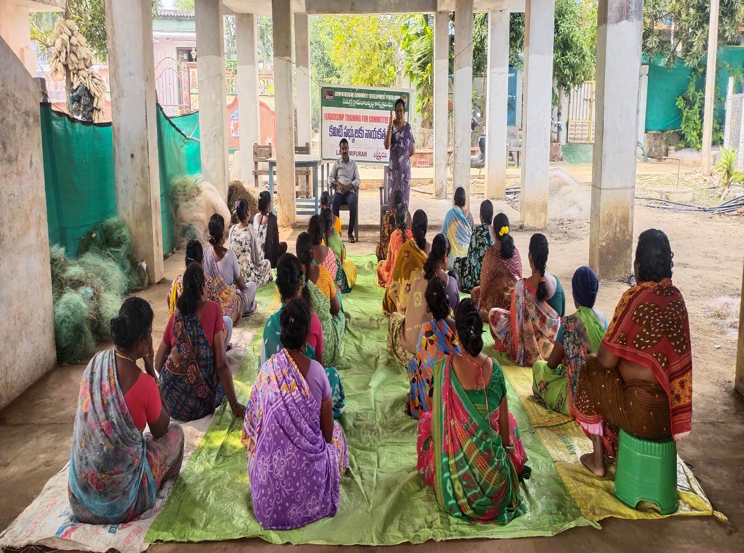
Leadership Training Camp for Committee Members
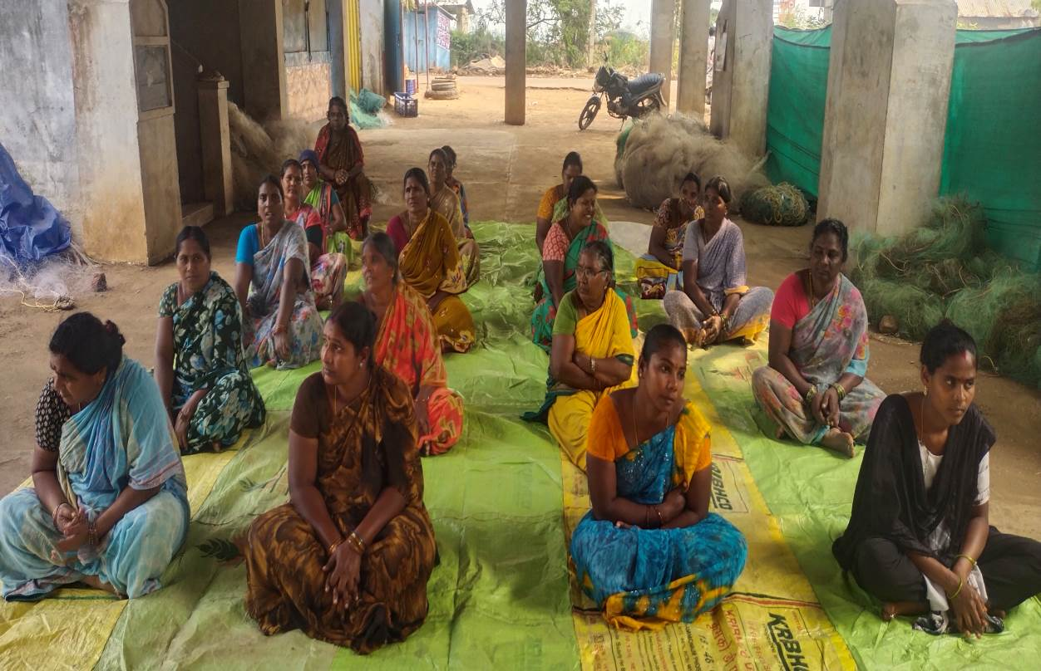

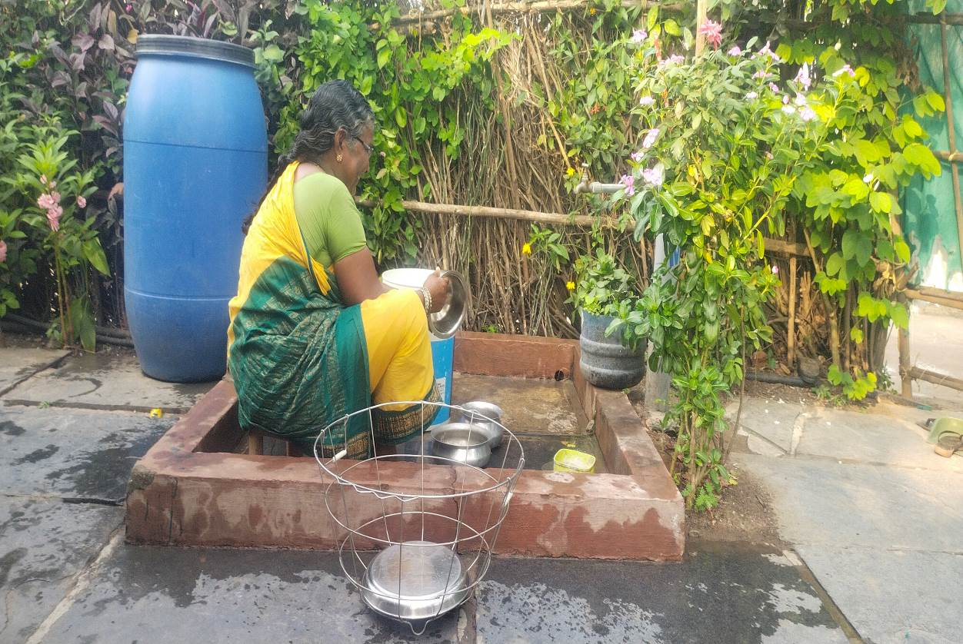
Washing Platforms
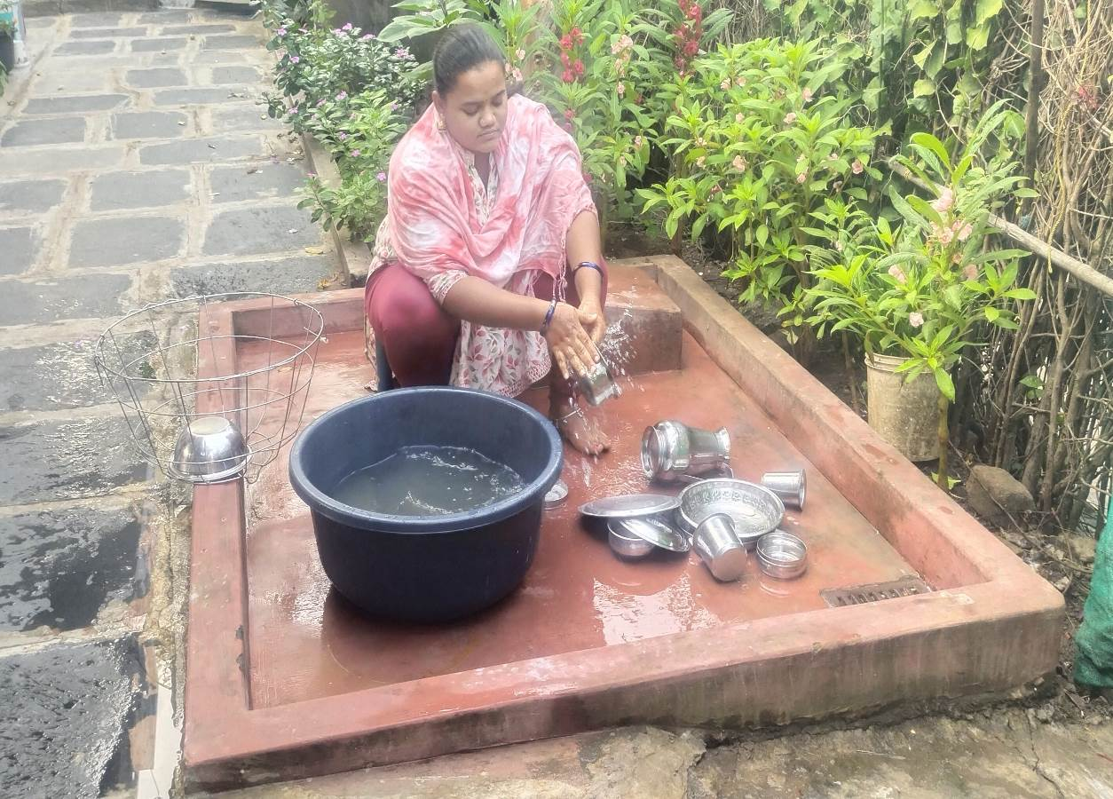

Kitchen Gardens
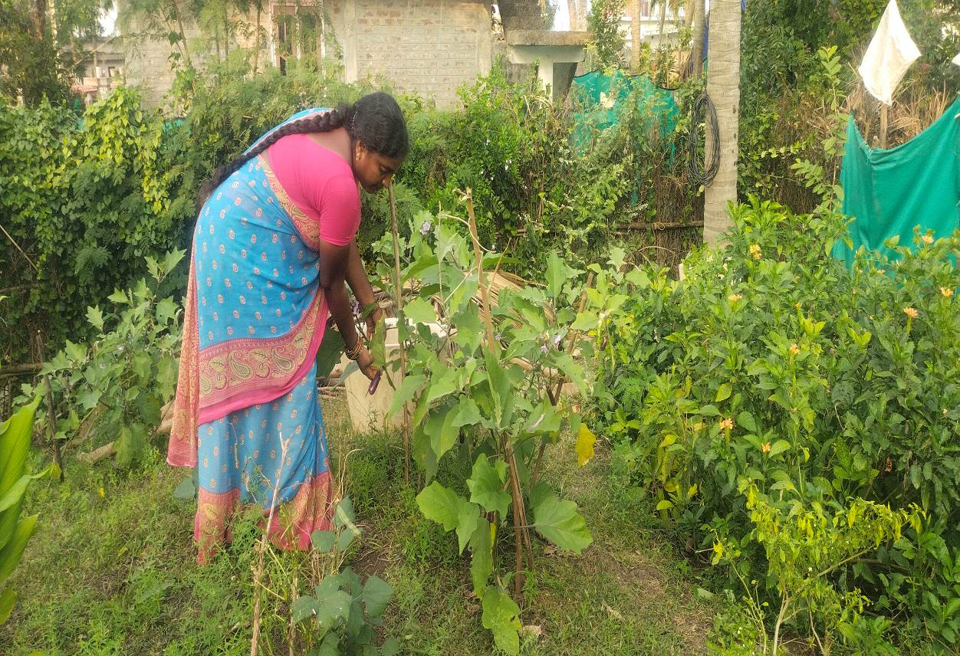

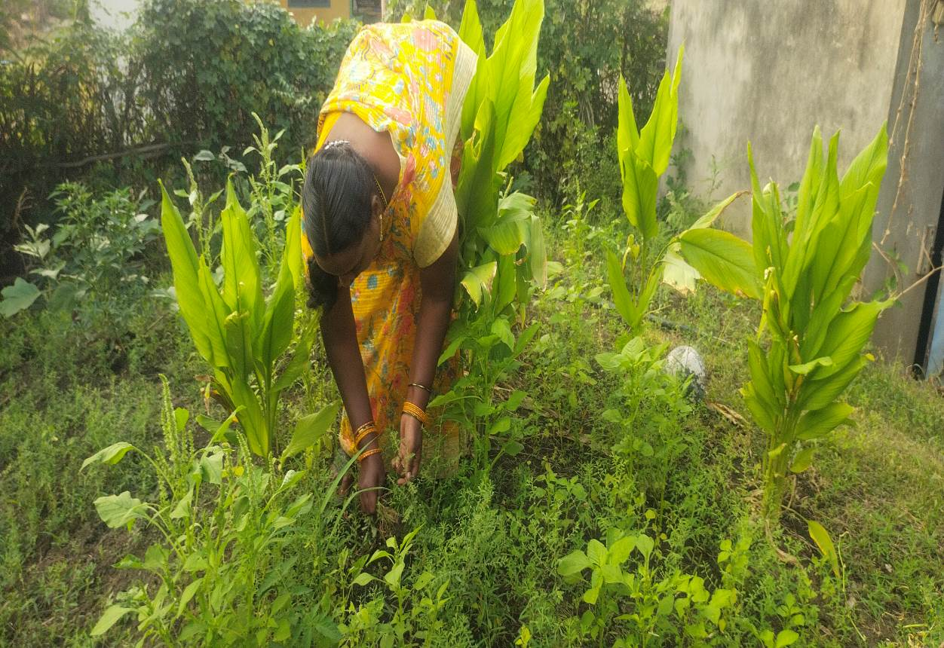

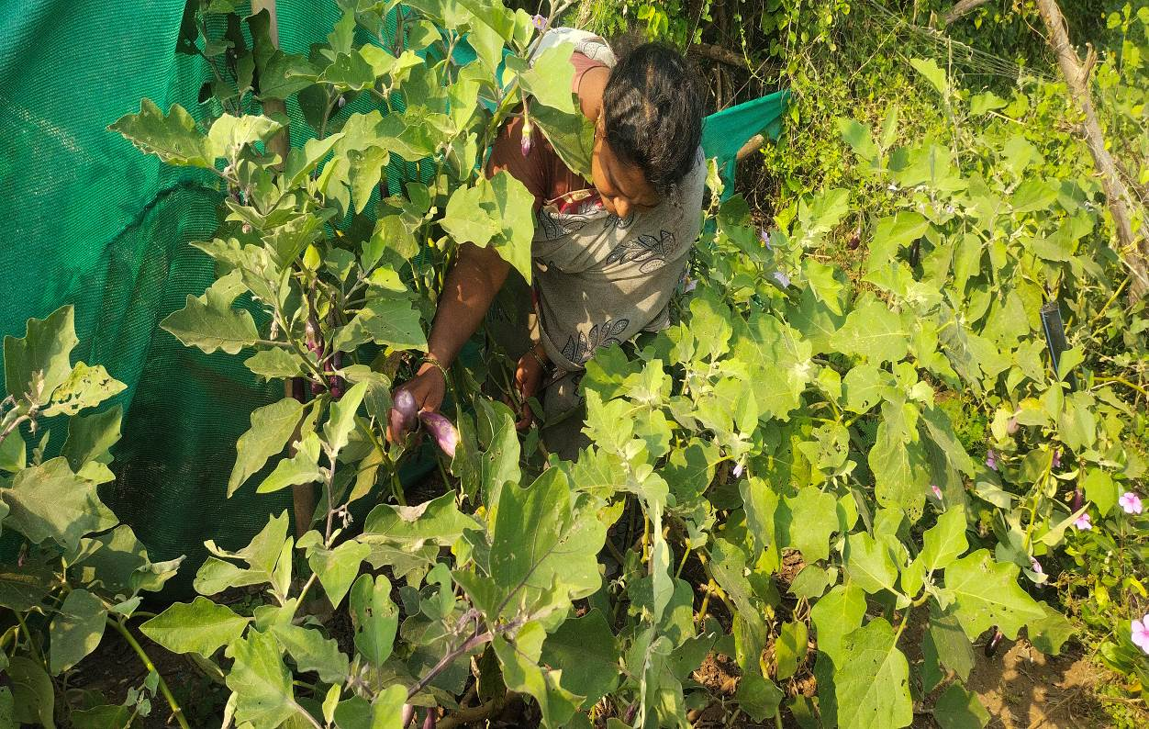

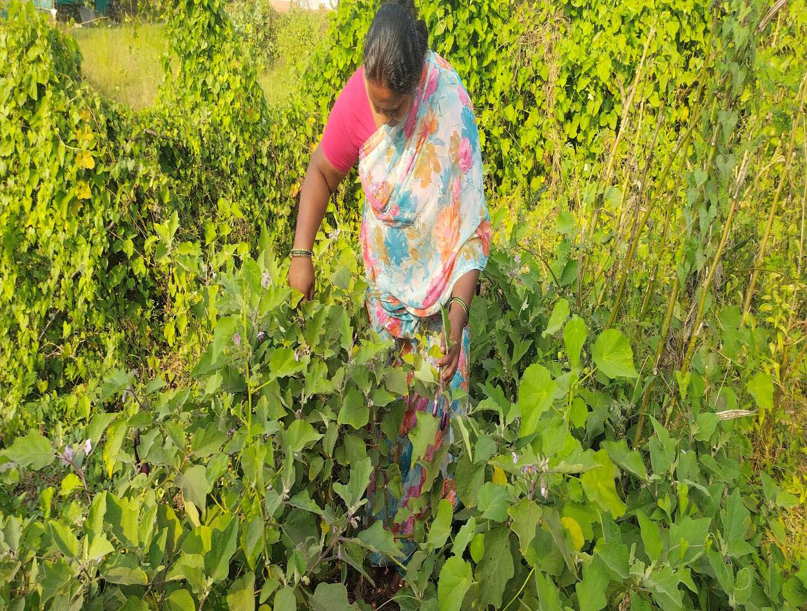

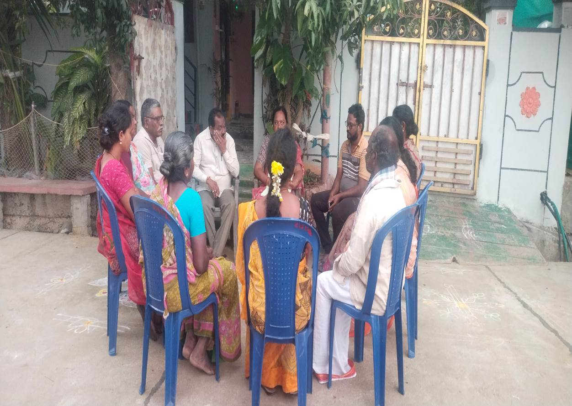
Monthly Meeting of VDS Committee Members
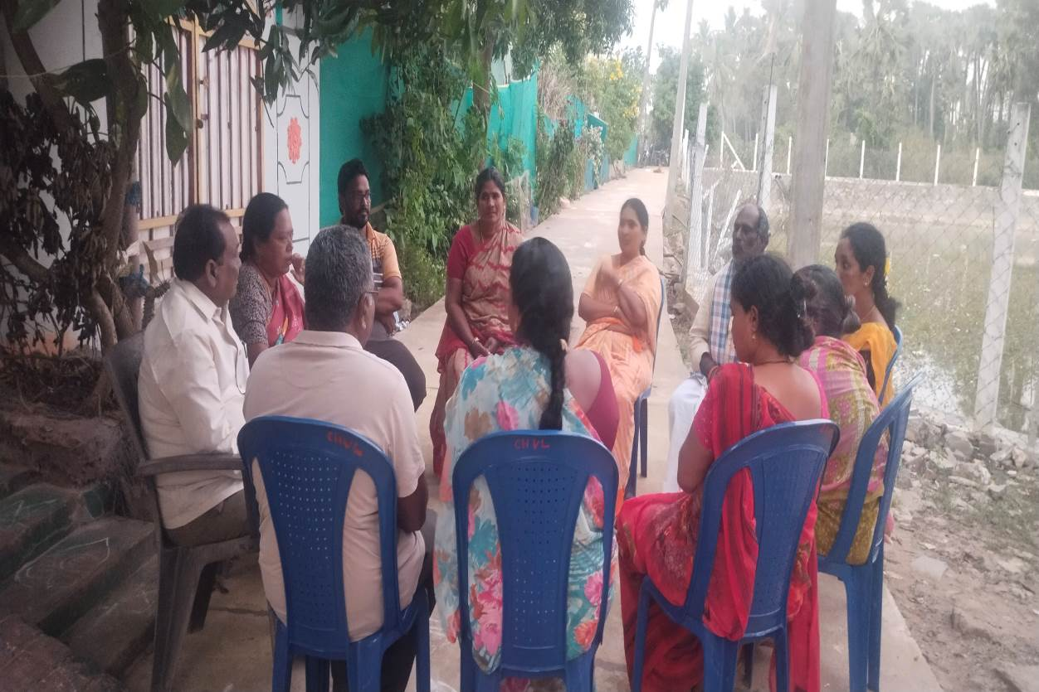

Visit of Revenue Minister
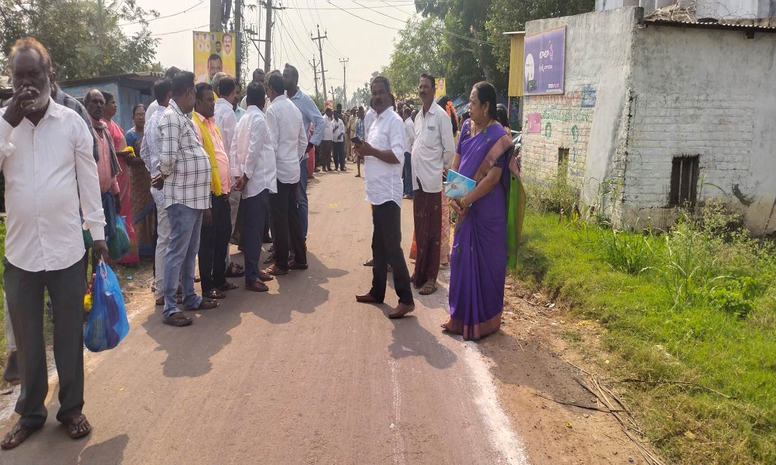

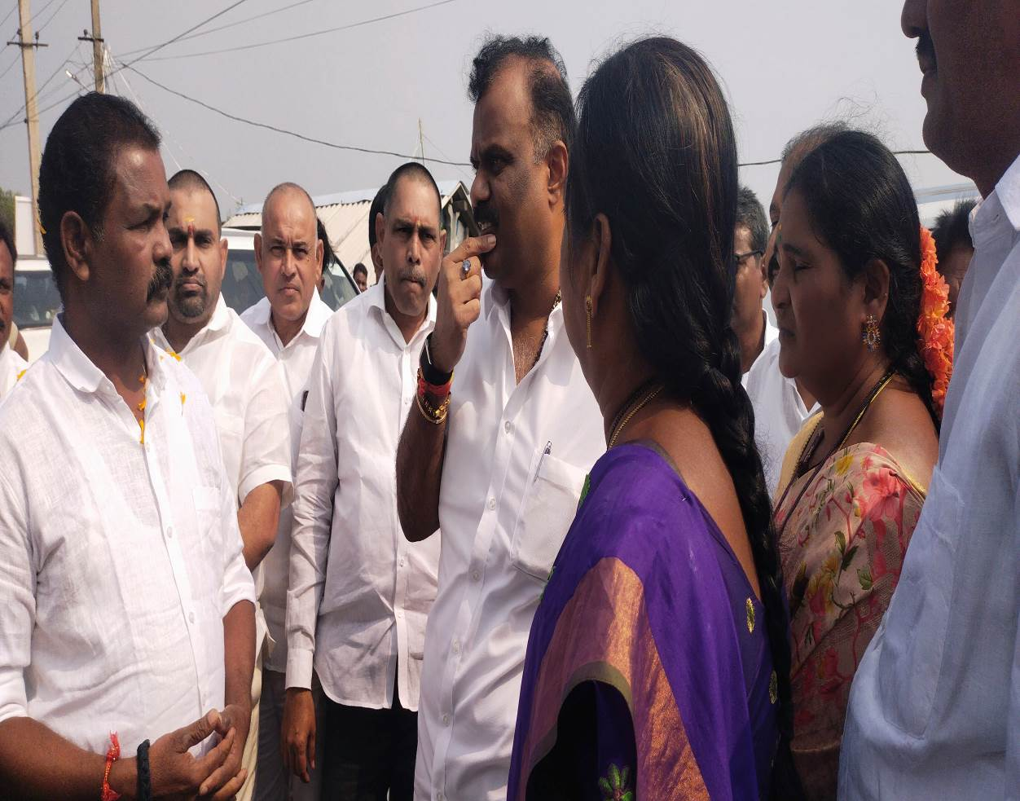
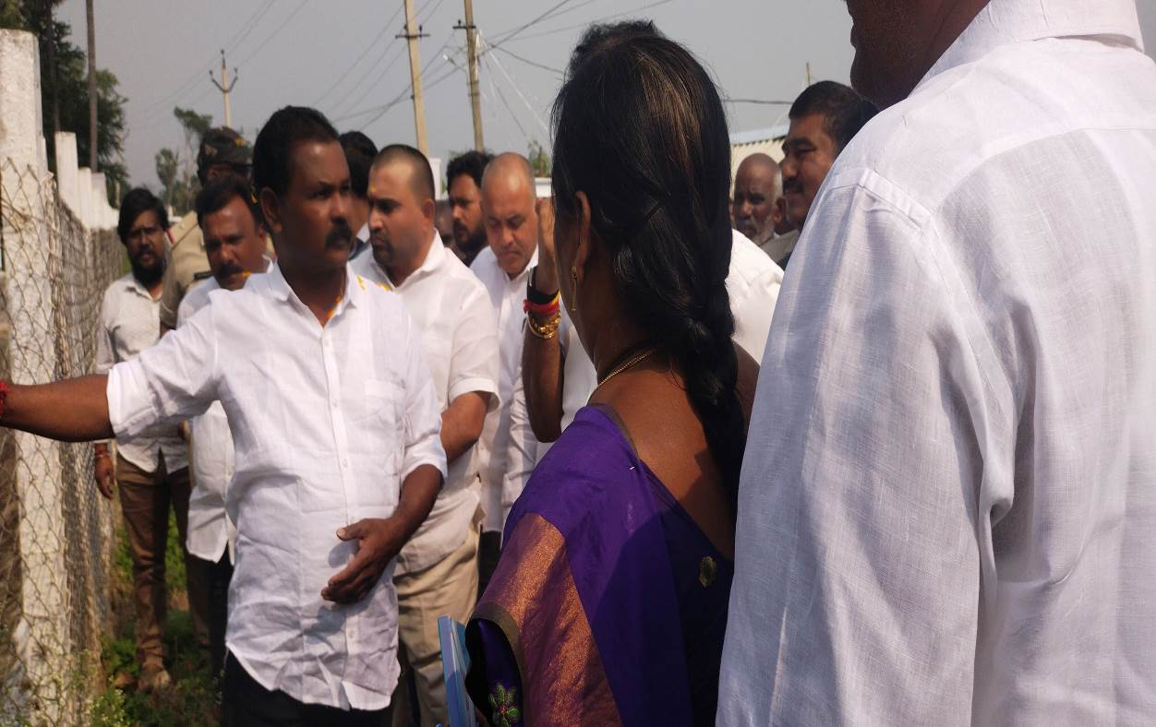

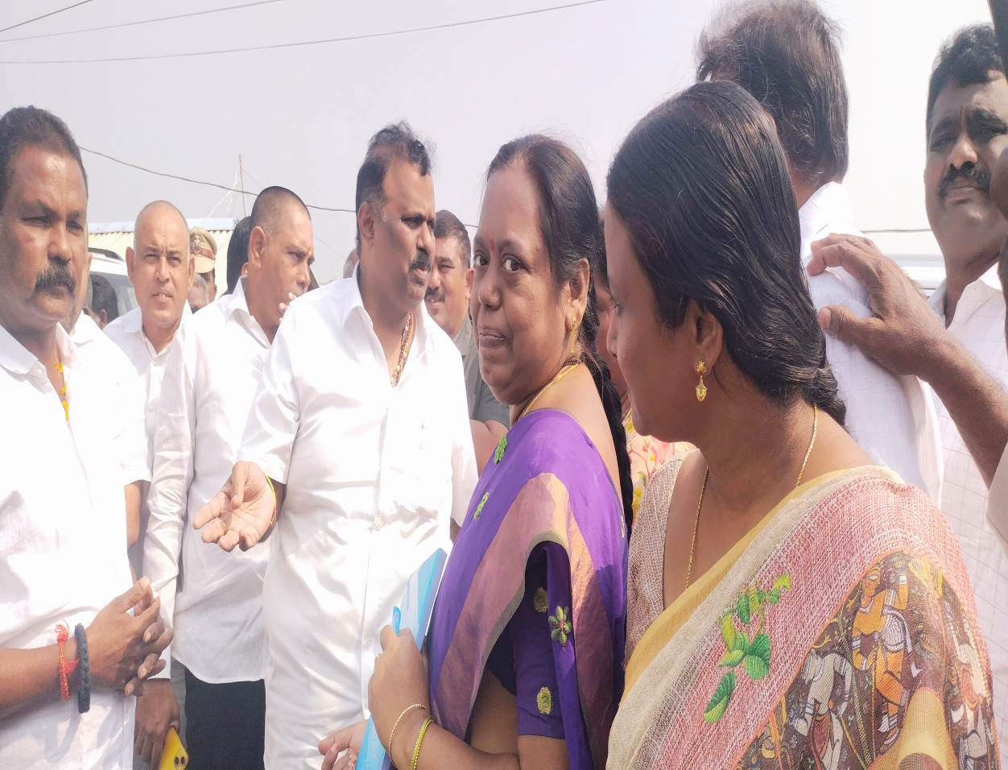

Village Cleaning
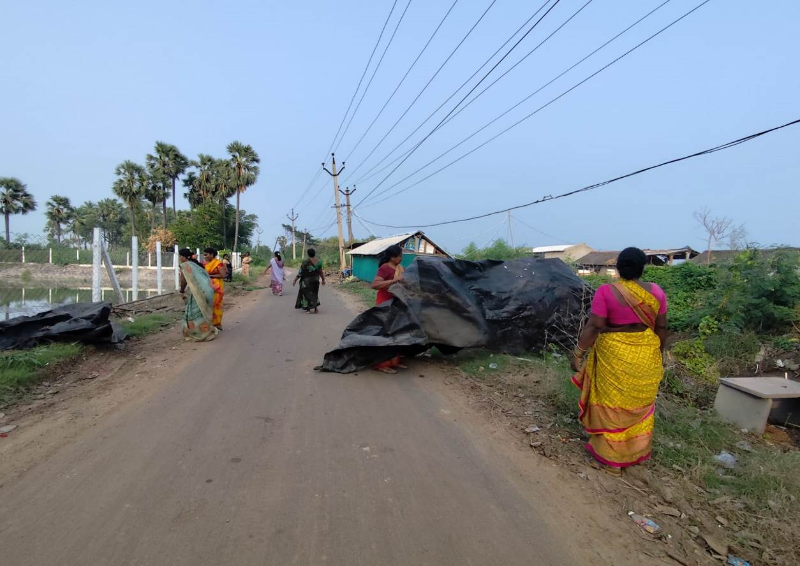

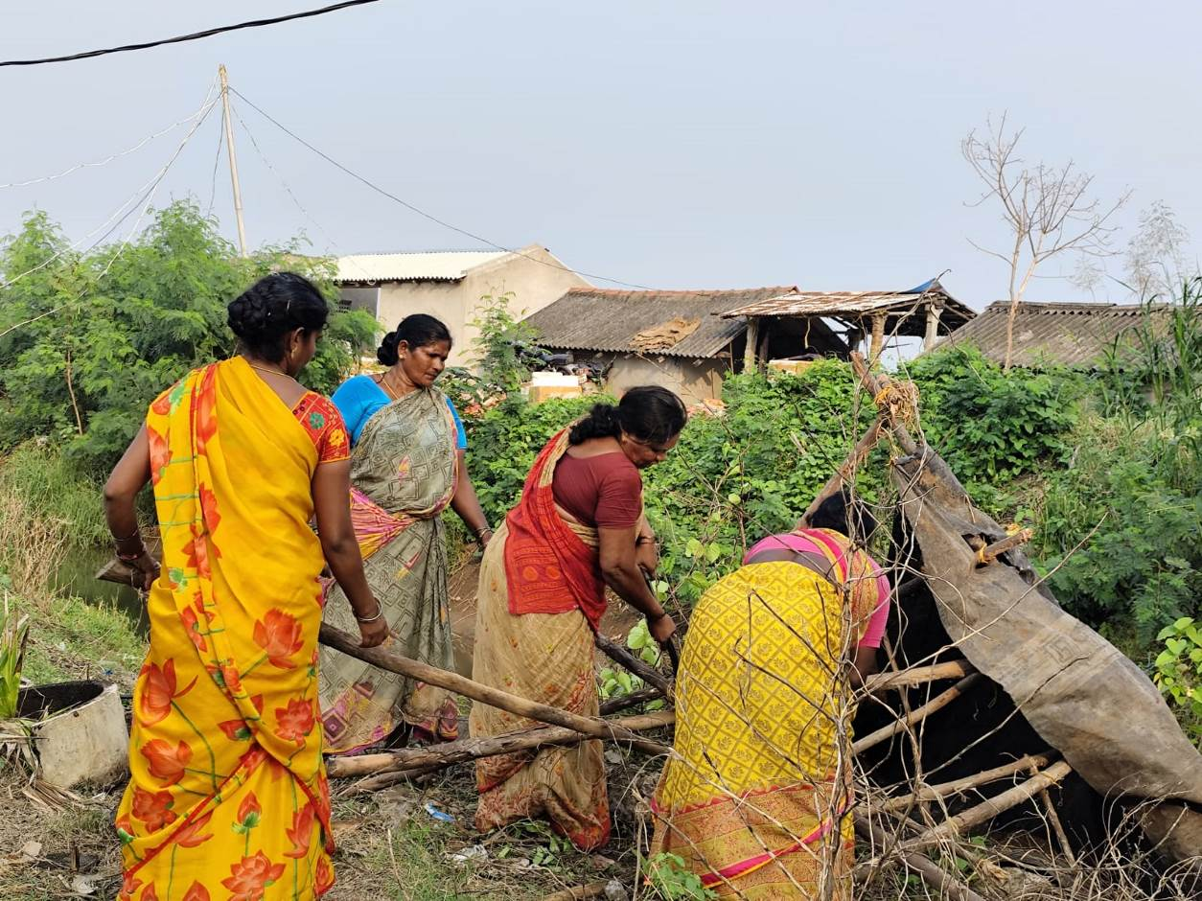
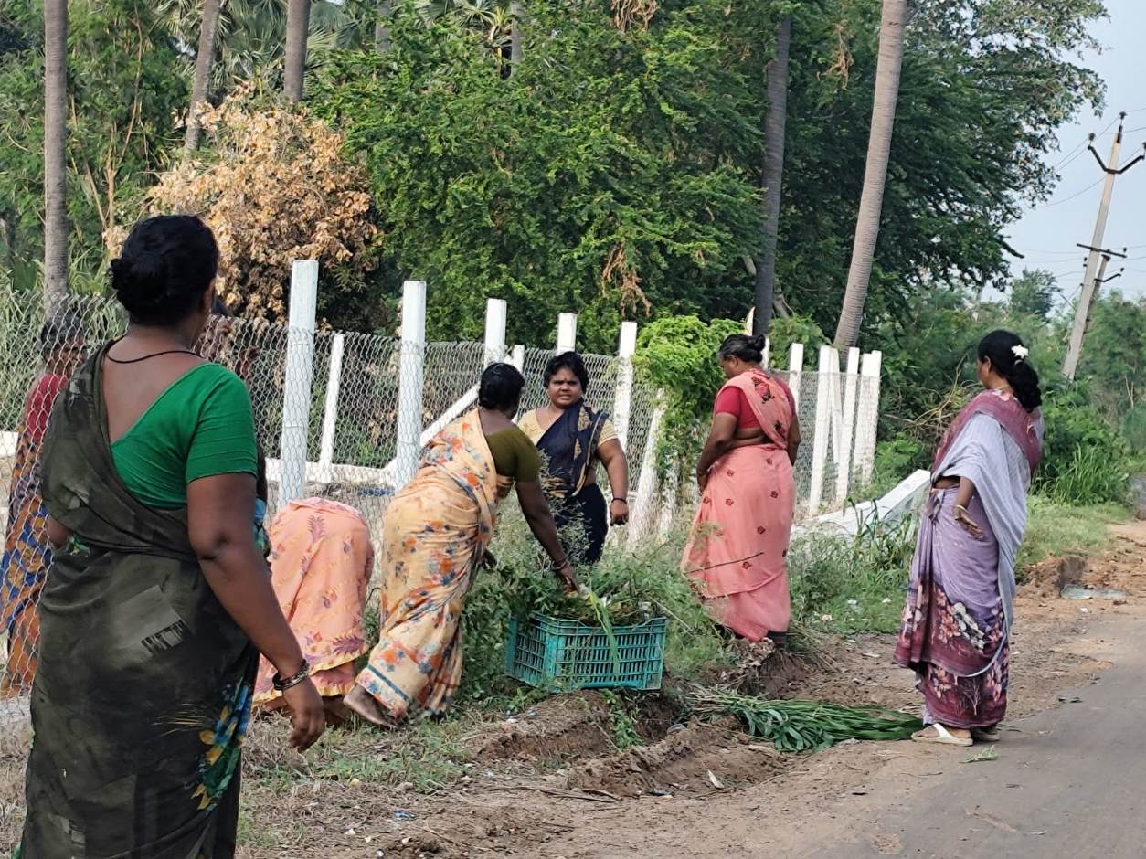

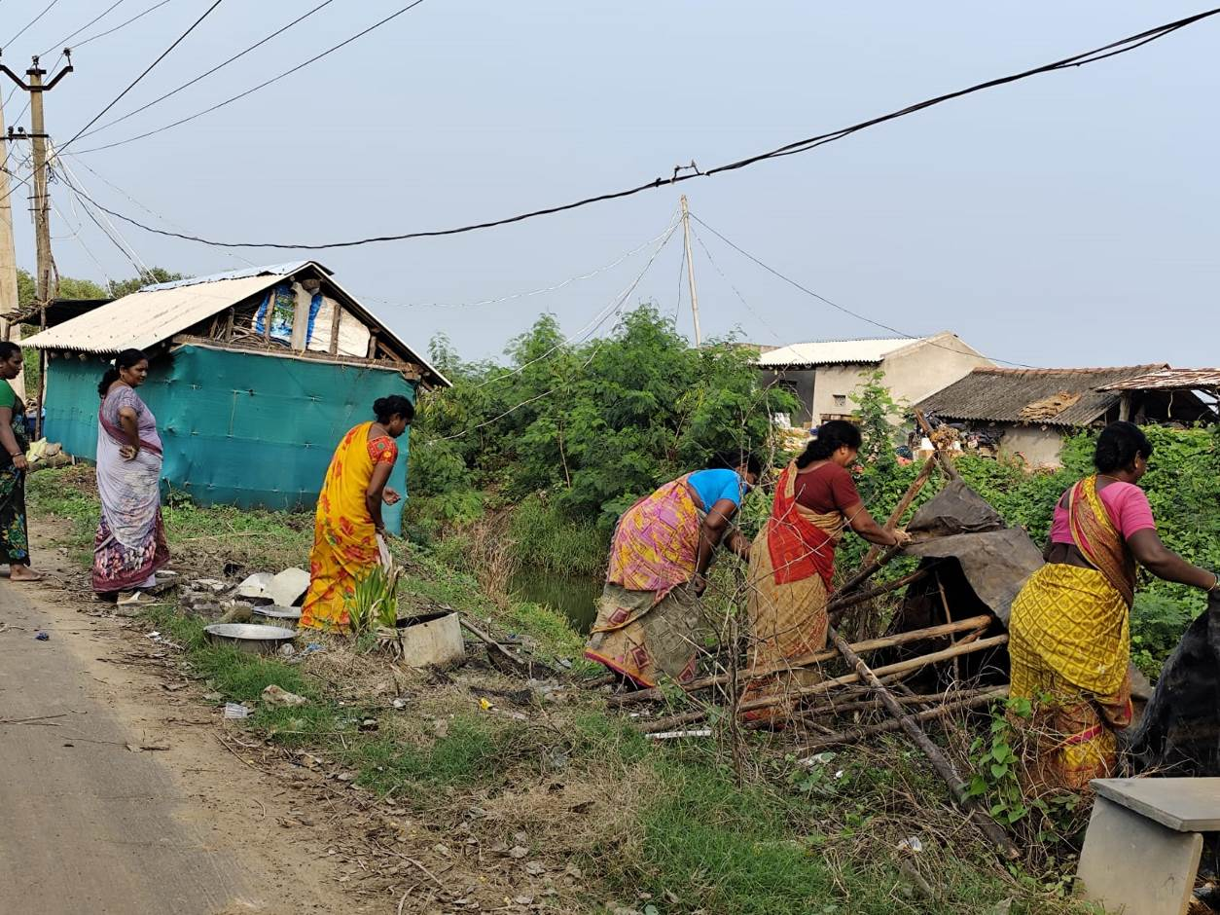
Income Generation Units
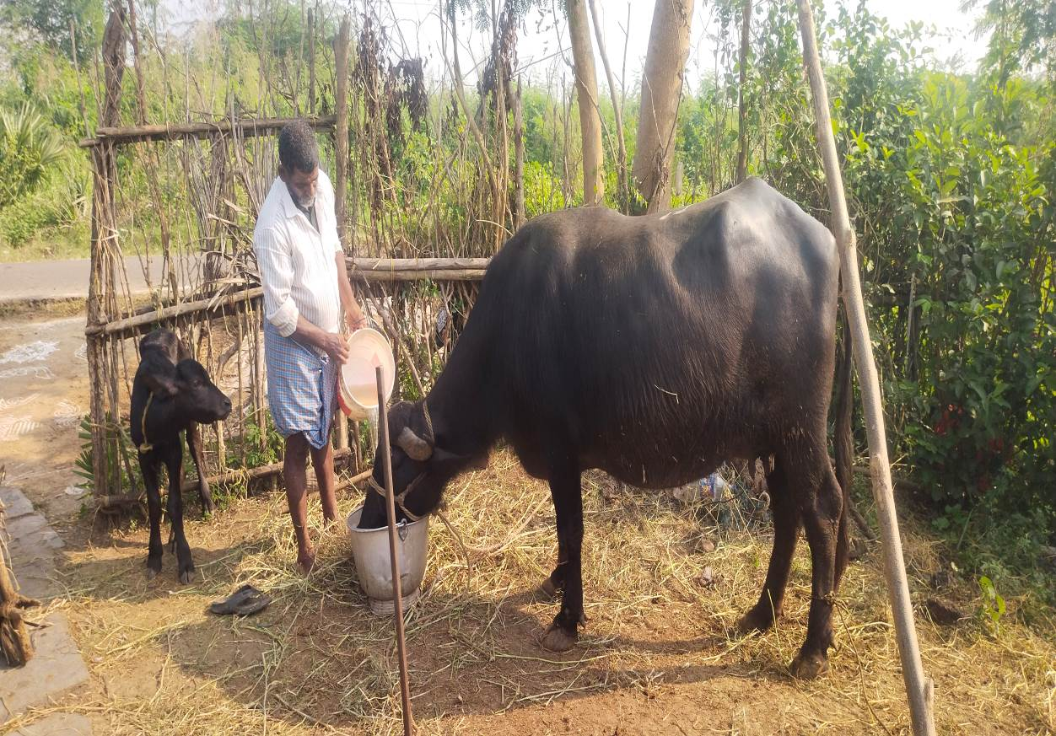

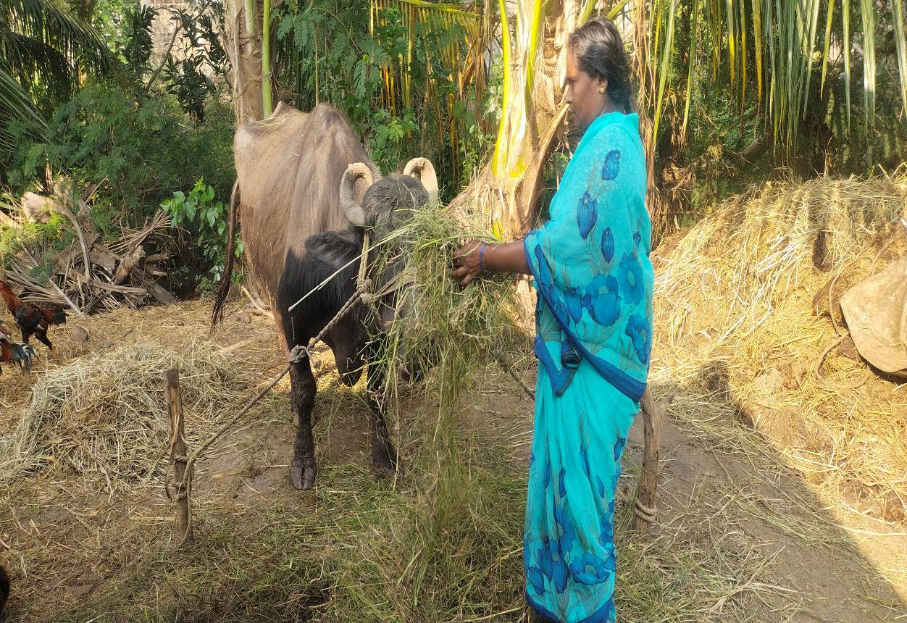

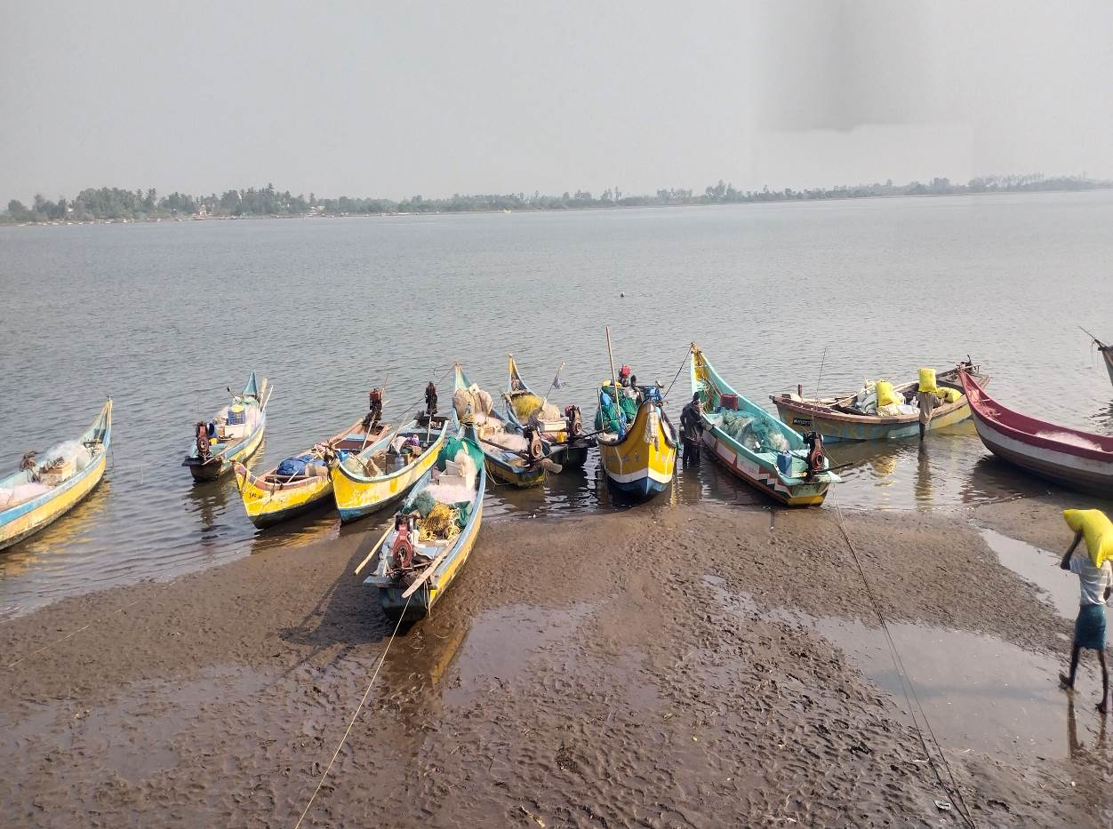

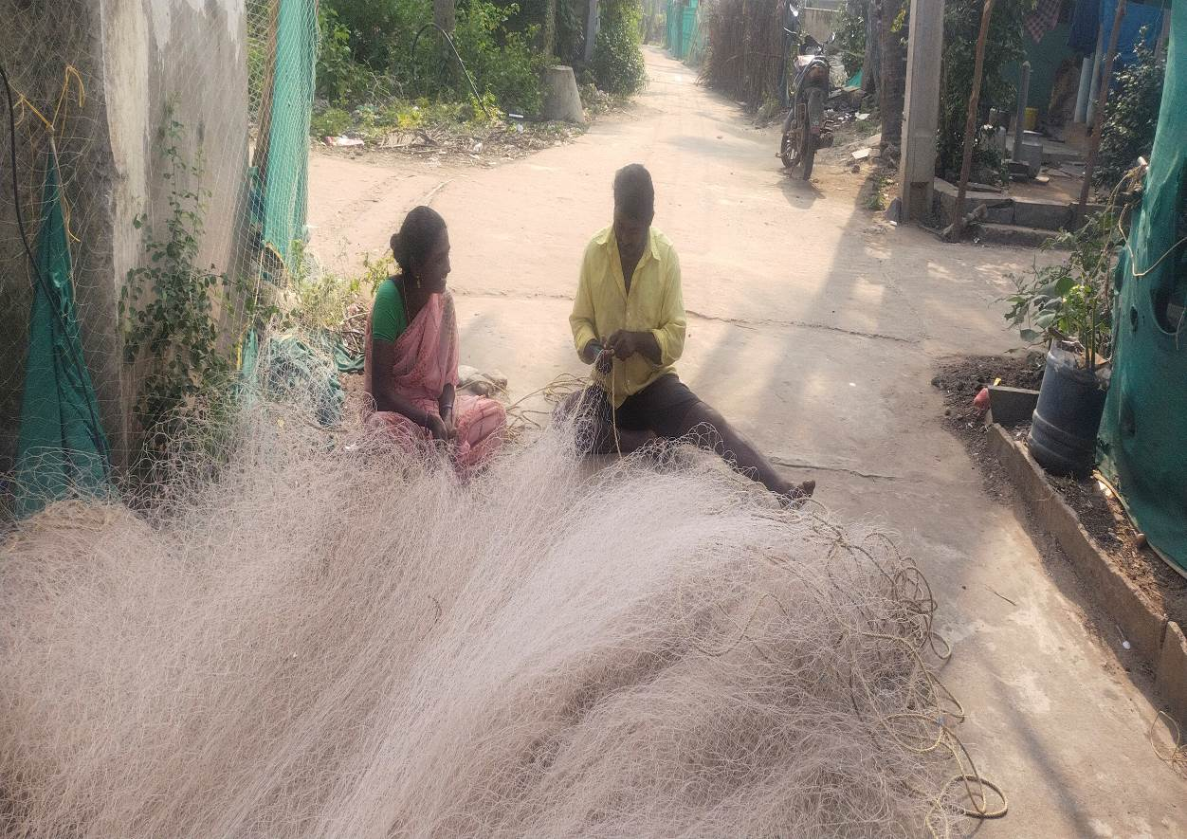

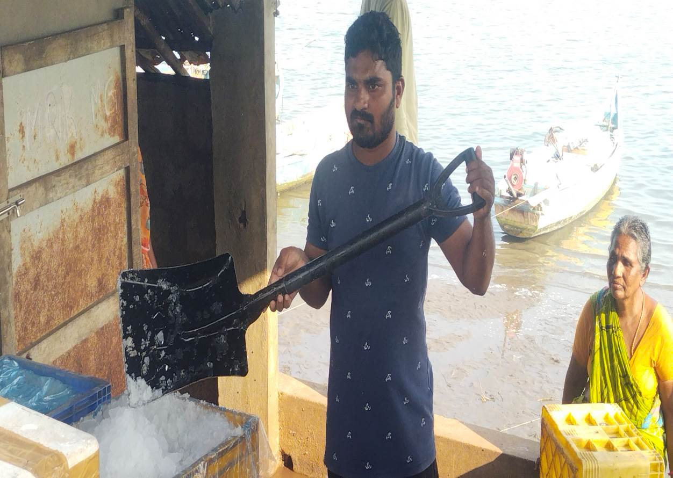

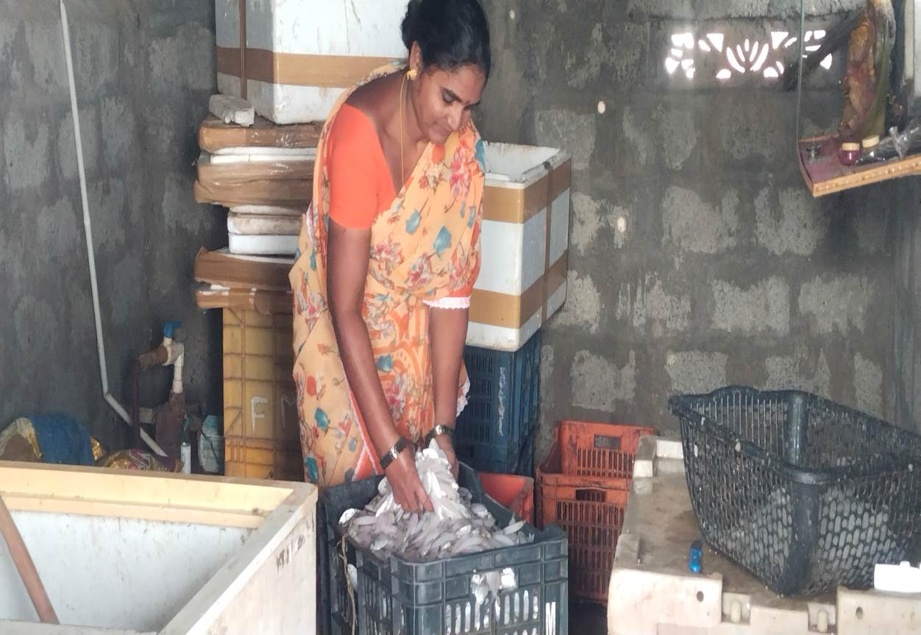

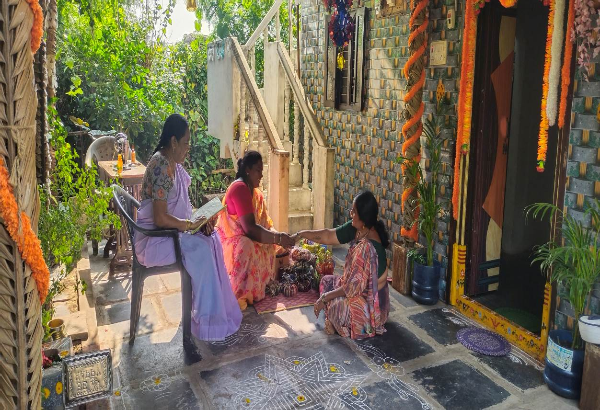

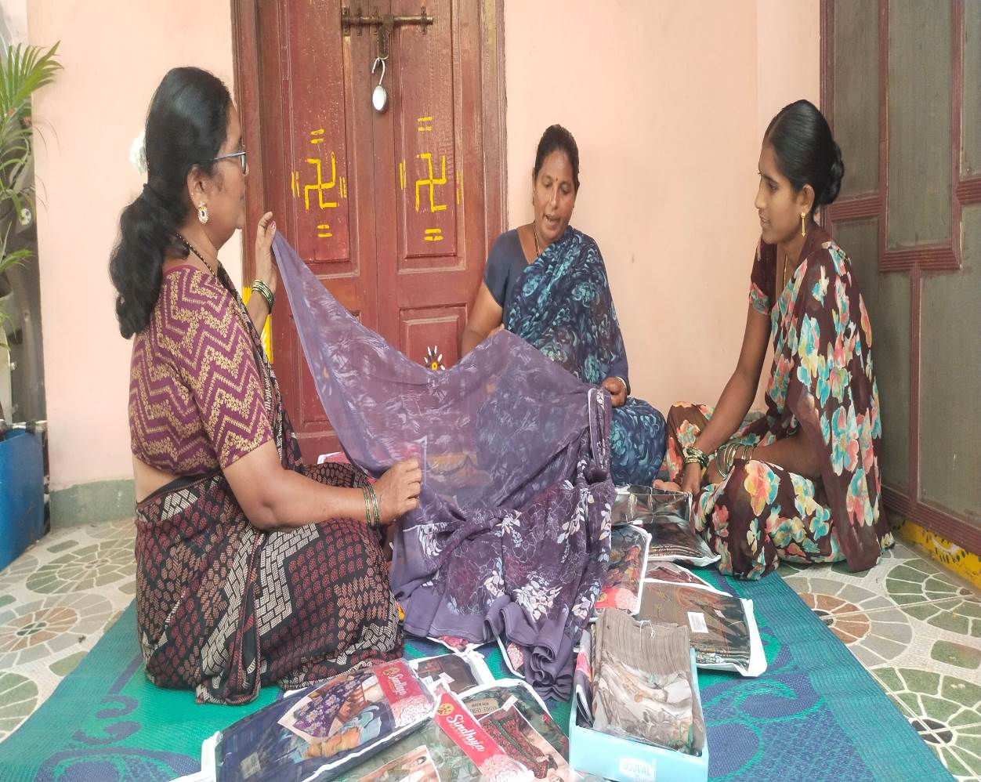

Agriculture
